PowerMatcher i3 Core

Installation and Configuration

Authors: Carlo Haverkamp (IBM)

Release: 0.5




Document version: 2
Date: 4-9-2012

Table of Contents
1. Introduction 7
2. PowerMatcher Core overview 8
2.1 Core components 8
2.2 Adapters 8
2.3 Run-time environments 9
3. PowerMatcher Core configuration for OSGi 10
3.1 Component configuration in OSGi 10
3.2 Manual Configuration using the Web Console 10
3.3 Configuration using XML 11
3.3.1 Concept 12
3.3.2 Processing the node configuration 13
3.3.3 Configuration XML 13
3.3.4 Configuration and Property elements 14
3.3.5 Node Configuration 15
4. PowerMatcher stand-alone application configuration 17
4.1 Configuration using property files 17
4.2 Configuring the component properties 17
4.3 Running the stand-alone application 17
5. Creating a PowerMatcher configuration 19
5.1 OSGi configuration example 19
5.1.1 Manual configuration using the web console 19
5.1.2 Configuration using XML 21
5.2 Stand-alone property file example 23
6. Development environment setup 25
6.1 Install a Java JDK 25
6.2 Eclipse download and install and setup 25
6.3 Installing the Bndtools plug-in 26
6.4 Lotus Expeditor Client installation 26
6.5 Retrieving the source code 27
6.6 IDE Setup 28
6.7 Importing the sources 31
6.8 Code style and formatting preferences 32
6.9 Launching the application from the workbench 33
6.9.1 Run as a stand-alone application 33
6.9.2 Run as an OSGi application 33
6.10 Building a PowerMatcher application 34
6.10.1 Build the stand-alone application 34
6.10.2 Build the PowerMatcher Core OSGi bundle jars 35
7. Appendix A: PowerMatcher Components 37
7.1 Core components 37
7.1.1 Auctioneer 37
7.1.2 Concentrator 37
7.1.3 Clipping concentrator 37
7.1.4 CSV Logging agent 38
7.1.5 Objective agent 38
7.1.6 Test agent 39
7.1.7 Broker Manager 39
7.1.8 Micro broker bridge 39
7.2 Component Adapters 40
7.2.1 Market Basis Adapter 40
7.2.2 Agent Adapter 41
7.2.3 Matcher Adapter 41
7.2.4 MQTT v3 connection adapter 42
7.2.5 MQTT v5 connection adapter 42
7.2.6 Log Listener adapter 43
7.2.7 Telemetry Adapter 43
7.3 ConfigManager component 43
8. Appendix B: OSGi runtime installation and setup 45
8.1.1 Pax Runner installation and setup 45
8.1.2 Install the required bundles 46
8.1.3 Install the application bundles 46
8.1.4 Configure the run time properties 47
8.1.5 Logback logging configuration 47
8.1.6 Install and run the MQTT broker 48
8.1.7 Configure the PowerMatcher application 49
8.1.8 Starting the OSGi environment 49
9. Appendix C: Configuration XML schema 50
10. Appendix D: Example configurations 52
10.1 PowerMatcher Core minimal configuration 52
10.1.1 Minimal configuration using XML 52
10.1.2 Minimal configuration using a properties file 54
11. References 55

Table of Figures
Figure 1 The Configuration tab in the Apache Felix Web Console. 11
Figure 2 The dialog for creating or editing configuration records. 11
Figure 3 Example configuration specification. 13
Figure 4 Lotus Expeditor Client installation wizard start screen. 27
Figure 5 Lotus Expeditor Client installation wizard screen for changing setup defaults. 27
Figure 6 Bndtools wizard for creating a configuration project named ‘cnf’. 29
Figure 7 Select the Stand Configuration template for the 'cnf' project. 29
Figure 8 The 'cnf' project created by Bndtools prefilled with common bundles. 30
Figure 9 Add the MicroBroker jar files to the Bndtools repository. 30
Figure 10 Eclipse preferences import wizard. 32
Figure 11 Build all Core bundles with the build.xml script in project 'com.ibm.matrixv.osgi'. 36

Version History

Version | Description | Author
1 | PowerMatcher release version 0.5 | C. Haverkamp (IBM)
2 | PowerMatcher release version 0.5. Revised and extended document. | C. Haverkamp (IBM)

Introduction
The PowerMatcher I3 Core offers a framework for developing PowerMatcher based systems. It provides all the base components of the PowerMatcher concept: auctioneer, concentrator, objective agent and interfaces and framework classes to develop your own PowerMatcher enabled device agents. For logging purposes the framework contains also a CSV Logging Agent and a Test Agent for demonstration purposes.

PowerMatcher systems can be developed as stand-alone applications or run on the OSGi platform. The latter is a runtime environment where the PowerMatcher components are deployed as modules and where each module provides services and may have dependencies on other modules or on configuration data.

Running your PowerMatcher system on the OSGi platform offers the possibility of dynamically configuring and updating your system and supports a distributed architecture. Configurations can be stored in XML files and can be updated while the system is operating. The PowerMatcher ConfigManager component running within OSGi provides regularly checks the configuration and updates the configuration objects in the OSGi runtime. OSGi will restart components with updated configuration settings automatically, without aborting current transactions.

Systems initially designed as stand-alone PowerMatcher applications can be upgraded to the OSGi platform. It just requires implementing the OSGi component interface for you custom made device agent, the installation and set up of an OSGi runtime and creating a ConfigManager configuration version for your PowerMatcher application.

The next transition could be moving the system to the Cloud which is provided by the PowerMatcher i3 as a Service framework[1]. This document only covers the Core framework.

This document describes how to install and configure a PowerMatcher system and development environment. It provides an overview of the available components and adapters and their configuration properties. The different alternatives for configuring the system is explained by creating a sample configuration which can be the start of your own PowerMatcher based application.

PowerMatcher Core overview

Core components
The basis of a PowerMatcher application is formed by a set of components that will provide the core PowerMatcher functionality. This set consists of the following components:

- Auctioneer
The auctioneer component creates an auctioneer instance, which will receive all the bids of the other agents as a single bid or as an aggregate bid via one or more concentrators. It is responsible for defining and sending the market basis and calculating the equilibrium based on the bids from the different agents in the topology. This equilibrium is communicated to the agents down the hierarchy in the form of price update messages.
- Concentrator
The concentrator is a factory component from which several instances can be created. The network of agents can be divided into several groups of agents, each group having their own concentrator. The concentrator receives the bids from the agents and forwards this in an aggregate bid up in the hierarchy to a concentrator or to the auctioneer directly. It will receive price update messages from the auctioneer and forward them to its connected agents.
A special type of concentrator component, the Clipping Concentrator, can limit the power consumption of its group to a certain configurable level.
- Objective agent
This component influences the market price and the power consumption to a configurable value.
- MicroBroker agent
All communication between the components is done via a service bus using the MQTT-protocol. The MicroBroker agent manages the creation of a MicroBroker MQTT bus. The agent supports different micro broker implementations.
- CSV Logging agent
This agent subscribes to status, telemetry, price update and bid log messages and stores them in a comma separated file (csv-file).
- Test agent
Though the purpose of PowerMatcher Core is to provide a framework to design your own PowerMatcher based applications with custom developed device agents, it also contains a Test Agent for testing your initial setup.

Adapters
The core components are accompanied by a set of adapter components that are required by the core components. The following adapters are provided:

- Market basis adapter
This adapter creates het market basis that on which all bid and price update messages are based upon. The adapter is used by the auctioneer only.
- Agent Protocol adapter
The ability to communicate bids to matchers (auctioneers and concentrators) is provided by this adapter component. The communication protocol is configurable, but should match the protocol of the matcher.
- Matcher Protocol adapter
A matcher component (auctioneer or concentrator) can receive bids from its connected agents through its Matcher Protocol adapter. The communication protocol is configurable and should match the communication protocol of the Agent Protocol adapter of its connected agents.
- MQTT connection adapter
The agent’s connection to the MicroBroker MQTT bus is managed by the MQTT connection adapter. Each agent in the PowerMatcher topology requires this adapter. There are two different adapters, a version 3 and a version 5 adapter, depending on the version of the MQTT protocol that is being used on the service bus.
- Telemetry adapter
The capability of sending or receiving telemetry data is added to an agent by this component. Device agents can report telemetry and other measurement data via this adapter. The CSV logging agent can receive telemetry data using this adapter.
- Log listener adapter
Enables the component to receive bid and price update log messages from a configurable topic. This adapter is used by the CSV Logging agent.

Run-time environments
There are two alternatives to run a PowerMatcher Core based application:
- Stand-alone Java application
Running the PowerMatcher application as a Java application just requires a platform that has a java runtime (JRE, version 5 or higher) installed. The application components (auctioneer, concentrator, device agents etc.) will be configured using a property file.
- PowerMatcher on an OSGi runtime environment
The PowerMatcher components are also supplied as bundles which can be deployed on an OSGi runtime environment. This requires an OSGi runtime environment, like for example Pax-Runner.
In both alternatives an MQTT broker is required. Examples of MQTT brokers are Micro Broker, which is part of Lotus Expeditor and Mosquito, an open source message broker.

PowerMatcher Core configuration for OSGi

Component configuration in OSGi
The OSGi runtime is based on a component model where components have dependencies that need to be resolved before they can be activated. The runtime provides a dependency injection framework where components are wired together to resolve these dependencies. Though this might seem very abstract it will be more clear when this is illustrated with an example using PowerMatcher core components.

An auctioneer component cannot be created and activated before a number of dependencies are fulfilled. First the auctioneer itself needs a configuration object that provides all required properties. Then the OSGi runtime will create an auctioneer object instance, although this object still has a number of dependencies to be resolved before it can be activated.

One defined dependency of the auctioneer is the MQTT connection adapter. In order to communicate with the MQTT service bus the auctioneer needs an MQTT connection adapter component instance. Like the auctioneer itself, this MQTT connection adapter instance can only be created when there is a configuration object. As soon this object is created the OSGi runtime will instantiate an MQTT object and since it has no other dependencies it can be activated also. The dependency injection framework of the OSGi runtime will now wire them together resolving the auctioneer’s MQTT connection adapter dependency.

PowerMatcher components are wired to their adapter components when they have the same ‘id’ property. For example an auctioneer with id auctioneer1 will be wired to the MQTT connection adapter with the same id. The MQTT connection is not sufficient for the auctioneer to operate. The activation of the auctioneer also requires that a Market Basis adapter and a Matcher Protocol adapter is created with the same id.

Creating a PowerMatcher Core application basically comprises the deployment of the PowerMatcher Core components as OSGi bundle jars in the OSGi runtime, deploying the custom made device agents and then create the configuration objects to instantiate and activate the components.

The following sections describe the alternatives to create these configuration objects.

Manual Configuration using the Web Console
Using the Apache Felix Web Console a configuration object can be created manually. Each configuration object for a component that is created with the web console is already prefilled with the default values.

To create a configuration record for a component open the Apache Felix Web Console (http://localhost:8080/system/console) and navigate to the Configuration tab. Find the component’s symbolic name in the list. Error: Reference source not found shows the configuration tab. Note that it displays the configuration records that are already created below the symbolic name of the component. Factory components have a ‘+’ button for creating multiple configuration records and a singleton component will only have one configuration record, hence the edit button (the pencil).

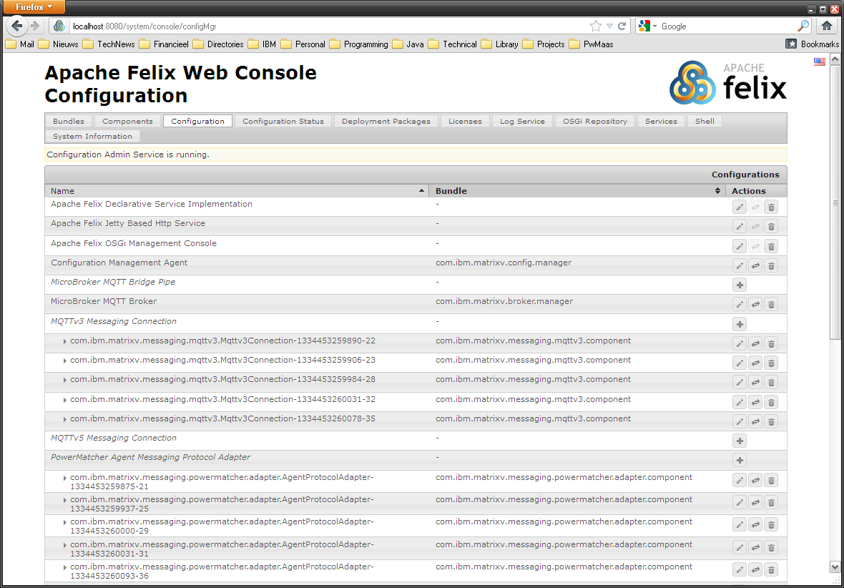
Figure 1 The Configuration tab in the Apache Felix Web Console.

Click the ‘+’ to create a new configuration record or the edit button for a single configuration record (e.g. for the MQTT Broker). The dialog that appears is already prefilled with default values (see the example in Error: Reference source not found). After you entered the properties click the Save button and the configuration record will be created. The Configuration Admin service will now instantiate component using the configuration data.

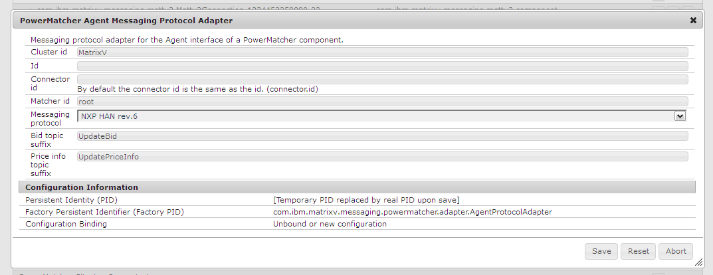
Figure 2 The dialog for creating or editing configuration records.

Configuration using XML
Specifying configurations using the Felix Web Console may be simple, when this procedure has to be repeated several times it is more sensible to do a configuration from a persistent resource like a file (note however that configurations in the OSGi runtime environment are persistent, but deploying a similar configuration on a different node requires creating a new configuration).

The PowerMatcher Core framework facilitates configuration of a complete PowerMatcher runtime environment using a single XML configuration file. This service is provided by the Configuration Manager Agent which is also an OSGi component itself. It processes the configuration specifications in the XML file and creates, updates or deletes configurations for the components by invoking the Configuration Admin service of the OSGi runtime.

Concept
The idea of the configuration of OSGi components is based around two main entities: Configuration Specifications and Node Configurations. The Configuration Specification defines the contents of an OSGi configuration object record. A node represents an OSGi runtime container instance that is the host of a set of components.

The Node Configuration defies the configuration records for this constellation of components in a node by linking to one or more Configuration Specifications. Each Configuration Specification can have multiple child configurations together forming a tree structure.

The actual values of the fields in the OSGi configuration record are defined using a third entity: a Property which contains a key-value pair where the key is the name of the field in the configuration record. A Configuration Specification can have multiple properties.

The Configuration Specification can have different roles and characteristics:

- Singleton Component Specification:
This type defines the configuration record of a singleton, component; a component from which only one instance can be created. The component record is created with a Persistent Identity (“PID”) that matches the components name. This will be also the identifier of the component instance in the OSGi container.
- Factory Component Specification:
Components types from which multiple component instances can be created are called ‘factory components’. The creation of configuration records will require in this case a factory PID, which is equal to the component name and an identifier which should be unique for only the configuration records of this component type (i.e. PID). Component Specifications of type factory are used to create this type of configuration records.
- A configuration group:
In this role the a Configuration Specification enables the logical grouping of Configuration Specifications. The configuration group can also define properties, which will be propagated to its child Configuration Specifications unless the child overrides that property.
- Component Specification Template:
In case many instances of the same component type need to be created, which share many properties having the same value, you can define a Configuration Specification that acts as a template. The properties of a template will be applied to a configuration when there is a template configuration with the same PID which is a child of one of the ancestors (parents) in the hierarchy of the template user.

Each node is running an OSGi container where a collection of components (or bundles) are deployed. The configuration for this node and its component instances is defined in the Node Configuration. However, the configuration of the components has to be done within the container, which means that each node requires also its own Configuration Management Agent.

Figure 3 demonstrates the configuration concept using a simple example. Suppose a company has a number of Windows and Linux servers that will be monitored by an agent that will be running in an OSGi container. There will be two agent types, a Windows Monitor Agent and a Linux Monitor Agent. From both types several agents will be instantiated, each monitoring one server. The Configuration Specification for these agent types will therefore be of type ‘factory’. The configuration specifications of the same type are grouped into a Configuration Group. Because many Windows and Linux Monitor Agents share the same configuration parameters for each agent type there is a configuration template defined.

There is one singleton Configuration Specification, which is the configuration for the Security Agent that will monitor the Directory Services and other security aspects. Since there is only one agent required, the type of this Configuration Specification is ‘singleton’.

The configuration the company’s monitoring agents is defined by the ‘Multi-system node’, this configuration contains the Windows and Linux Monitor Agent configurations and the Security Agent configuration.

Suppose the company has two daughter companies one having only Windows servers, the other solely running Linux servers. Both have also monitor agents for their servers. The company running Windows servers can configure the agents with the ‘Windows cluster node’ configuration and the other can use the ‘Linux Cluster Node’ configuration. Since they share the network facility with their parent company they do not require a security agent. If they didn’t the definition of the Linux and Windows cluster nodes could have also added the Security Agent configuration.

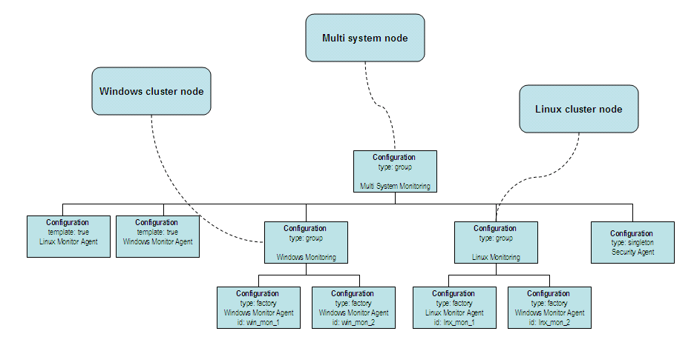
Figure 3 Example configuration specification.

Processing the node configuration
The Configuration Management Agent will inspect the node configuration. If the configuration is valid it will process it and invoke the Configuration Admin service with information requests about the current configuration records. In case a configuration specification has no matching configuration record in the container it will request the Configuration Admin service to create that configuration. If it already exists the properties of the runtime configuration instance are compared with the version in the node configuration. In case there are changes found, the configuration record will be updated. Configuration records that have no matching specification in the node configuration will be deleted.

The Configuration Management Agent implementation for PowerMatcher demands that each configuration specification has an ‘id’ and a ‘cluster.id’ property. The id is required to match runtime configuration records with their specification counterparts in the node configuration.

Configuration XML
The input of the Configuration Management Agent is a node configuration. This node configuration is an XML structure that is defined by a schema or XSD (see to section 9Appendix C: Configuration XML schema).

The XML structure of contains elements that match the entities mentioned earlier in the description of the concept. A node configuration xml structure will contain the following elements:

- configuration
- property
- nodeconfig

The XML representation of a Node Configuration is a tree structure of configuration elements below the node. The following XML excerpt shows an example of a Node Configuration:
<?xml version="1.0" encoding="UTF-8"?>
<nodeconfig id="pwm_core_demo_node" name="PwM Core Demo node"
description="PowerMatcher core demo node" date="2012-06-13">
<configuration type="group" id="root">
<configuration type="group" cluster="DemoPwmCore" id="demo_pwm_core">
<property name="cluster.id" value="Test" type="String"></property>
<configuration type="group" cluster="DemoPwmCore" id="broker_definitions">
<configuration type="singleton" cluster="DemoPwmCore"
pid="com.ibm.matrixv.broker.manager.BrokerManager" id="MicroBroker">
<property name="broker.name" value="Demo_Pwm_Core_MicroBroker"
type="String"></property>
</configuration>
</configuration>
<configuration type="group" cluster="DemoPwmCore" id="testagent1_grp">
<configuration type="factory" cluster="DemoPwmCore"
pid="com.ibm.matrixv.agent.powermatcher.framework.test.TestAgent"
id="testagent1">
<property name="id" value="testagent1" type="String"></property>
</configuration>
<configuration type="factory" cluster="DemoPwmCore"
pid="com.ibm.matrixv.messaging.telemetry.adapter.TelemetryAdapter"
id="testAgent1_telemetry_adapter">
<property name="id" value="testagent1" type="String"></property>
</configuration>
<configuration type="factory" cluster="DemoPwmCore"
pid="com.ibm.matrixv.messaging.mqttv3.Mqttv3Connection"
id="testAgent1_MqttConnection">
<property name="id" value="testagent1" type="String"></property>
</configuration>
<configuration type="factory" cluster="DemoPwmCore"
pid="com.ibm.matrixv.messaging.powermatcher.adapter.AgentProtocolAdapter"
id="testAgent1_AgentAdapter">
<property name="matcher.id" value="concentrator1" type="String"></property>
<property name="messaging.protocol" value="HAN_rev6" type="String"></property>
<property name="id" value="testagent1" type="String"></property>
</configuration>
</configuration>
<configuration type="group" cluster="DemoPwmCore" id="objective_agent_grp">
<configuration type="factory" cluster="DemoPwmCore"
pid="com.ibm.matrixv.messaging.mqttv3.Mqttv3Connection"
id="objective_agent_mqtt_connection">
<property name="id" value="objectiveagent1" type="String"></property>
</configuration>
. . .

Configuration and Property elements
The Configuration Specification entity is represented in the XML structure by the configuration element. The element has an attribute ‘pid’ that will identify the component type (i.e. it will contain the component name).

The following example shows an configuration example of a PowerMatcher auctioneer component (component name is ‘com.ibm.matrixv.agent.powermatcher.auctioneer.Auctioneer’):

<configuration type="factory" cluster="demo"
pid="com.ibm.matrixv.agent.powermatcher.auctioneer.Auctioneer" id="auctioneer1">
<property name="id" value="auctioneer1" type="String" />
<property name="bid.expiration.time" value="300" type="Integer" />
<property name="update.interval" value="30" type="Integer" />
<property name="cluster.id" value="Demo" type="String" />
<property name="enabled" value="true" type="Boolean" />
</configuration>

The attributes ‘id’ and ‘cluster’ identify the Configuration Specification entity and have no relation to the configuration data for the component configuration record. The latter is specified by the property elements which are placed as child elements of the configuration element. The ‘name’ and ‘type’ attributes of the property element should be equal to the property name and type of the component configuration record respectively.

The configuration element has a ‘type’ attribute which can have the values ‘singleton, ‘factory’ and ‘group’.
In the example above it is defined that the Auctioneer component is a factory component, which can have multiple instances within an OSGi container. The Configuration Admin will create a configuration record using the value in the PID as a factory PID. It will generate a unique id, consisting of the component name and a unique value, and assign it to the ‘pid’ field of the configuration record. In case it would have been a singleton component, the PID of the configuration record would have been equal to the component name.

A ‘group’ type configuration can logically group other configurations together. However it is also a means of defining a set of common properties for all child configurations within that group. If the properties are placed at the root configuration group they are similar to ‘global’ properties in a programming language. For example, the property “enabled” of the Auctioneer example configuration above could have been defined at the root. This would have the effect that all PowerMatcher components are enabled by default. In case for a specific component this is not desired, the property can simply be overridden by redefining the property in the child configuration.

A configuration can act as a template configuration when the optional attribute ‘template’ is set to true. In case one of the child configurations of a group configuration is a template, then all child configurations of with the same PID as the template inherit its properties. A template will only be applied to a configuration when the template is a child of the configuration’s ancestor and not when it is a grand child.

For example in a PowerMatcher configuration many components require a connection adapter for MQTT, each having the same attributes except the id. Then it may be sensible to define a template (note the optional attribute template is now set, the default is false):

<configuration type="factory" cluster="demo" template=”true”
pid="com.ibm.matrixv.messaging.mqttv3.Mqttv3Connection" id="mqtt_connection_template">
<property name="reconnect.interval" value="10" type="Integer" />
<property name="lwt_message" value="" type="String" />
<property name="lwt_topic" value="false" type="Boolean" />
<property name="cluster.id" value="Demo" type="String" />
<property name="lwt_enabled" value="false" type="Boolean" />
<property name="broker.uri" value="tcp://localhost:1883" type="String" />
</configuration>

If you create configurations whose ancestor is the parent of the template configuration you only need the following definition to create an MQTT adapter component:

<configuration type="factory" cluster="demo" pid="com.ibm.matrixv.messaging.mqttv3.Mqttv3Connection" id="auctioneer1MqttConnection">
<property name="id" value="auctioneer1" type="String" />
</configuration>

All other properties will be inherited and need not to be defined unless you want override it.

Node Configuration
A PowerMatcher runtime environment is called a node and is identified by a node id. The Node Configuration is represented by the nodeconfig element in the XML structure. The configurations that make up the node configuration definition are placed as child elements within the nodeconfig element.

The XML excerpt below shows an example Node Configuration (element nodeconfig).

<?xml version="1.0" encoding="UTF-8"?>
<nodeconfig id="pwm-demo-basic" name="PWM Demo Basic Configuration"
description="PWM Demo Basic minimal configuration" date="2012-04-13">
<configuration type="group" id="pwm_demo_global">
<property name="commodity" value="electricity" type="String" />
<property name="update.interval" value="10" type="Integer" />
<property name="currency" value="EUR" type="String" />
<configuration type="group" cluster="demo" id="pwm-basic">
<configuration type="group" cluster="demo" id="testagent1_grp">
<configuration type="factory" cluster="demo"
pid="com.ibm.matrixv.messaging.powermatcher.adapter.AgentProtocolAdapter"
id="testAgentAgentAdapter">
…
</configuration>
...

</configuration>
</configuration>
</configuration>
</nodeconfig>

The id attribute of nodeconfig contains the id that uniquely identifies the node. The name and description attributes provide additional information and the date field contains the date when the node configuration XML was created.

PowerMatcher stand-alone application configuration

Configuration using property files
A PowerMatcher application can also run as a stand-alone application. When running it without the support of the Pax-Runner OSGi framework you will not have the flexibility of updating the configuration dynamically or benefit from the provisioning function provided by the Apache ACE module. However, the setup and the configuration is very straight forward and simple using a Java properties file.

Running a PowerMatcher application as a stand-alone application (Java main) requires a configuration stored in a Java properties file. The properties file should be named ‘agent_config.properties’ and should be located in the same directory as the directory from where the application is started.

A stand-alone application will not require the configuration of the adapters as is required when running it as an OSGi application. The program that reads the property file and starts the components automatically adds the required adapters. It will also start a broker manager.

Configuring the component properties
In the agent_config.properties file the individual components can be configured using the ‘agent.’ prefix in the property name before the id of the component. The syntax for a property setting for a component:
agent.<component_id>.<component_property>

The type of a component is defined by the ‘class’ component property name. In the following example the configuration properties specify the configuration of a Concentrator with id ‘concentrator1’ which is connected to the auctioneer with id ‘auctioneer1’.

# Concentrator properties
agent.concentrator1.class=com.ibm.matrixv.powermatcher.concentrator.Concentrator
agent.concentrator1.id=concentrator1
agent.concentrator1.matcher.id=auctioneer1

The PowerMatcher framework will instantiate a component of the type specified in the class property and assign the other properties. The ‘matcher.id’ property is a property of the agent protocol adapter which is automatically added to the concentrator. Contrary to the OSGi version, the required adapters will be created automatically. The adapters will automatically get the same id (i.e. ‘concentrator1’) but the agent protocol adapter links an agent to a matcher which requires that the ‘matcher.id’ property has is set. The other adapters, the MQTT connection adapter and the matcher adapter will get the same id as the concentrator and can run using only the defaults. You can override the defaults by adding the adapter property with the ‘agent.<component id>’ prefix.

It is also possible to specify global properties by omitting the ‘agent.<component id>’ prefix. For example, the same cluster id, location id and update interval can be defined for all agents specifying the following ‘global’ properties:

# Global property defaults
cluster.id=MatrixV
location.id=MatrixV
update.interval=10

Running the stand-alone application
<explain here how to start and stop the stand-alone application>

The stand-alone application can be started from the directory where it is deployed using the following command from the command shell prompt:

java -jar matrixvdemoapp.jar

In case you want to specify another or an additional configuration file you can specify:
java -jar matrixvdemoapp.jar -agentConfig my_project_agent_config.properties

Creating a PowerMatcher configuration
A basic Power Matcher runtime environment consists of the components that are delivered with the PowerMatcher Core distribution. That is an Auctioneer, a Concentrator, an Objective Agent and a CSV Logging agent. We also need at least one agent that implements the PowerMatcher protocol which sends regular bid updates. For our basic configuration we will use the Test Agent that is included with PowerMatcher Core. This section describes how to create a configuration for such a runtime setup.

The OSGi framework will instantiate a component when the required dependencies are fulfilled. For example, an Auctioneer requires next to an Auctioneer configuration also a Matcher adapter configuration, a Market Basis Adapter and a MQTT connection adapter.

The following table lists the components and the required component adapters for which a configuration has to be created in order to activate the component:

Component | Main component | Adapter
Broker | MicroBroker MQTT Broker Manager | -
Auctioneer | PowerMatcher Auctioneer | PowerMatcher Matcher Messaging Protocol
Auctioneer | PowerMatcher Auctioneer | PowerMatcher Market Basis
Auctioneer | PowerMatcher Auctioneer | MQTTv3 Messaging Connection
Concentrator | PowerMatcher Concentrator | PowerMatcher Matcher Messaging Protocol
Concentrator | PowerMatcher Concentrator | PowerMatcher Agent Messaging Protocol
Concentrator | PowerMatcher Concentrator | MQTTv3 Messaging Connection
Objective Agent | PowerMatcher Objective Agent | PowerMatcher Agent Messaging Protocol Adapter
Objective Agent | PowerMatcher Objective Agent | PowerMatcher Matcher Messaging Protocol
Objective Agent | PowerMatcher Objective Agent | Telemetry Messaging Adapter
Objective Agent | PowerMatcher Objective Agent | MQTTv3 Messaging Connection
CSV Logging Agent | PowerMatcher CSV Logging Agent | Telemetry Messaging Adapter
CSV Logging Agent | PowerMatcher CSV Logging Agent | MQTTv3 Messaging Connection
CSV Logging Agent | PowerMatcher CSV Logging Agent | Log Listener adapter
Test Agent | PowerMatcher Test Agent | PowerMatcher Agent Messaging Protocol Adapter
Test Agent | PowerMatcher Test Agent | Telemetry Messaging Adapter
Test Agent | PowerMatcher Test Agent | MQTTv3 or MQTTv5 Messaging Connection
Table 1 The components and component adapters required for a basic PowerMatcher application.
In this section we will illustrate the creation of a basic PowerMatcher runtime using two methods: a web console and configuration using an XML configuration file.

OSGi configuration example

Manual configuration using the web console
Using the Apache Felix Web Console the configuration can be created manually. Each configuration object for a component that is created with the web console is already prefilled with the default values, which makes a quick setup very easy.

Open the Apache Felix Web Console (http://localhost:8080/system/console). Then navigate to the Configuration tab and find the configuration name as listed in the table. Click the ‘+’ to create a new configuration instance or edit a single configuration instance (e.g. for the MQTT Broker) and fill in the properties as specified in the table. Select the Save button to create the configuration.

Component | Required OSGi configurations (name/class name) | Set property
Broker | MicroBroker MQTT Broker / com.ibm.matrixv.broker.manager.BrokerManager | -
Auctioneer | PowerMatcher Auctioneer /  com.ibm.matrixv.agent.powermatcher.auctioneer.Auctioneer | Id: auctioneer1
Auctioneer | PowerMatcher Matcher Messaging Protocol Adapter /  com.ibm.matrixv.messaging.powermatcher.adapter.MatcherProtocolAdapter | Id: auctioneer1
Auctioneer | PowerMatcher Market Basis Adapter / com.ibm.matrixv.messaging.powermatcher.adapter.MatcherProtocolAdapter | Id: auctioneer1
Auctioneer | MQTTv3 Messaging Connection / com.ibm.matrixv.messaging.mqttv3.Mqttv3Connection | Id: auctioneer1
Concentrator | PowerMatcher Concentrator / com.ibm.matrixv.powermatcher.concentrator.Concentrator | Id: concentrator1
Concentrator | PowerMatcher Matcher Messaging Protocol Adapter /  com.ibm.matrixv.messaging.powermatcher.adapter.MatcherProtocolAdapter | Id: concentrator1
Concentrator | PowerMatcher Agent Messaging Protocol Adapter / com.ibm.matrixv.messaging.powermatcher.adapter.AgentProtocolAdapter | Id: concentrator1, Macher id: auctioneer1
Concentrator | MQTTv3 Messaging Connection / com.ibm.matrixv.messaging.mqttv3.Mqttv3Connection | Id: concentrator1
Objective Agent | PowerMatcher Objective Agent / com.ibm.matrixv.agent.powermatcher.objective.ObjectiveAgent | Id: objectiveagent1  Objective bid: (64,0);(64,-1000.0)
Objective Agent | PowerMatcher Matcher Messaging Protocol Adapter /  com.ibm.matrixv.messaging.powermatcher.adapter.MatcherProtocolAdapter | Id: objectiveagent1, Matcher listener id: auctioneer1
Objective Agent | PowerMatcher Agent Messaging Protocol Adapter / com.ibm.matrixv.messaging.powermatcher.adapter.AgentProtocolAdapter | Id: objectiveagent1, Macher id: auctioneer1
Objective Agent | Telemetry Messaging Adapter / com.ibm.matrixv.messaging.telemetry.adapter.TelemetryAdapter | Id: objectiveagent1
Objective Agent | MQTTv3 Messaging Connection / com.ibm.matrixv.messaging.mqttv3.Mqttv3Connection | Id: objectiveagent1
CSV Logging Agent | PowerMatcher CSV logging Agent / com.ibm.matrixv.agent.powermatcher.logging.CSVLoggingAgent | Id: csvloggingagent1
CSV Logging Agent | Telemetry Messaging Adapter / com.ibm.matrixv.messaging.telemetry.adapter.TelemetryAdapter | Id: csvloggingagent1
CSV Logging Agent | MQTTv3 Messaging Connection / com.ibm.matrixv.messaging.mqttv3.Mqttv3Connection | Id: csvloggingagent1
CSV Logging Agent | Log Listener Adapter / com.ibm.matrixv.messaging.powermatcher.adapter.LogListenerAdapter | Id: csvloggingagent1
Test Agent | PowerMatcher Test Agent / com.ibm.matrixv.agent.powermatcher.framework.test.TestAgent | Id: testagent1
Test Agent | PowerMatcher Agent Messaging Protocol Adapter / com.ibm.matrixv.messaging.powermatcher.adapter.AgentProtocolAdapter | Id: testagent1, Macher id: concentrator1
Test Agent | Telemetry Messaging Adapter / com.ibm.matrixv.messaging.telemetry.adapter.TelemetryAdapter | Id: testagent1
Test Agent | MQTTv3 Messaging Connection / com.ibm.matrixv.messaging.mqttv3.Mqttv3Connection | Id: testagent1
Table 2 Component properties to be defined in the web console for a minimal configuration.

The following figure displays the creation PowerMatcher Auctioneer configuration in the Web Console:

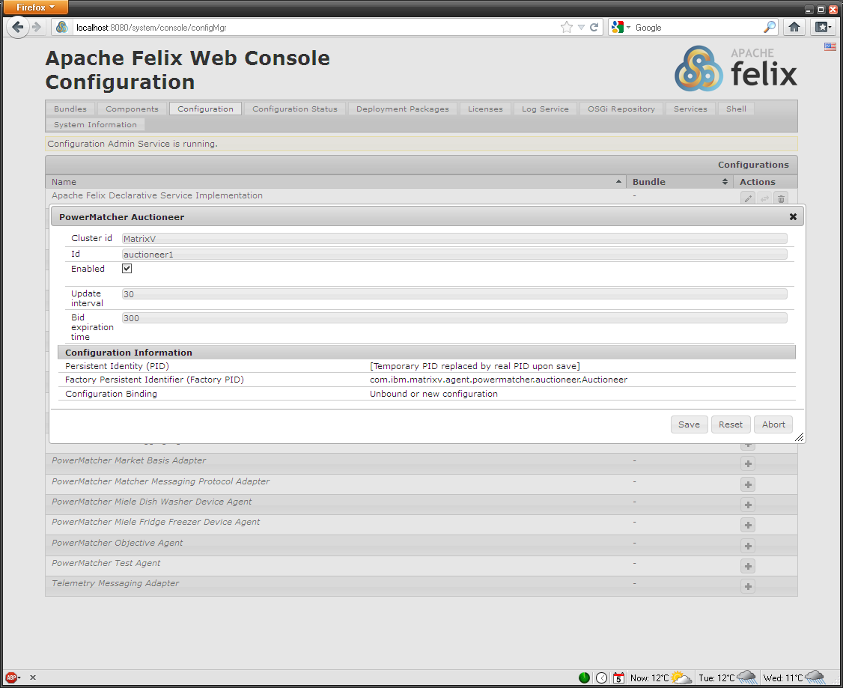

After configuration you can verify that a component is activated in the ‘Components’ tab of the Felix Web Console. All components and component adapters that you have configured should have the state ‘Active’.

Configuration using XML
The procedure that was followed in the previous section using the Apache Felix Web Console can also be captured into one XML file. In this section we will create an XML that will define the configurations for the same list of components and component adapters in Table 1. The XML configuration will contain the minimum of properties that need to be set. The properties that need to be set are shown in Table 3.

First we create XML header and the node configuration element with the name ‘sample_node’:

<?xml version="1.0" encoding="UTF-8"?>
<nodeconfig id="sample_node" name="Sample Core node"
description="Example basic PWM Core configuration using XML." date="2012-06-01">
</nodeconfig>

Then we add for each component listed in the table a configuration specification element as a child of the node element. For example:

<?xml version="1.0" encoding="UTF-8"?>
<nodeconfig id="sample_node" name="Sample Core node"
description="Example basic PWM Core configuration using XML." date="2012-06-01">
<configuration type="factory" cluster="DemoPwmCore"
pid="com.ibm.matrixv.agent.powermatcher.auctioneer.Auctioneer" id="auctioneer1">
<property name="id" value="auctioneer1" type="String"></property>
</configuration>
</nodeconfig>

Component | Required OSGi configurations (name/class name) | Set property
Broker | MicroBroker MQTT Broker / com.ibm.matrixv.broker.manager.BrokerManager | -
Auctioneer | PowerMatcher Auctioneer /  com.ibm.matrixv.agent.powermatcher.auctioneer.Auctioneer | id: auctioneer1
Auctioneer | PowerMatcher Matcher Messaging Protocol Adapter /  com.ibm.matrixv.messaging.powermatcher.adapter.MatcherProtocolAdapter | id: auctioneer1
Auctioneer | PowerMatcher Market Basis Adapter / com.ibm.matrixv.agent.powermatcher.marketbasis.adapter.MarketBasisAdapter | id: auctioneer1
Auctioneer | MQTTv3 Messaging Connection / com.ibm.matrixv.messaging.mqttv3.Mqttv3Connection | id: auctioneer1
Concentrator | PowerMatcher Concentrator / com.ibm.matrixv.powermatcher.concentrator.Concentrator | id: concentrator1
Concentrator | PowerMatcher Matcher Messaging Protocol Adapter /  com.ibm.matrixv.messaging.powermatcher.adapter.MatcherProtocolAdapter | id: concentrator1
Concentrator | PowerMatcher Agent Messaging Protocol Adapter / com.ibm.matrixv.messaging.powermatcher.adapter.AgentProtocolAdapter | id: concentrator1, matcher.id: auctioneer1
Concentrator | MQTTv3 Messaging Connection / com.ibm.matrixv.messaging.mqttv3.Mqttv3Connection | id: concentrator1
Objective Agent | PowerMatcher Objective Agent / com.ibm.matrixv.agent.powermatcher.objective.ObjectiveAgent | id: objectiveagent1  objective.agent: (64,0);(64,-1000.0)
Objective Agent | PowerMatcher Matcher Messaging Protocol Adapter /  com.ibm.matrixv.messaging.powermatcher.adapter.MatcherProtocolAdapter | Id: objectiveagent1, matcher.listener.id: auctioneer1
Objective Agent | PowerMatcher Agent Messaging Protocol Adapter / com.ibm.matrixv.messaging.powermatcher.adapter.AgentProtocolAdapter | id: objectiveagent1, matcher.id auctioneer1
Objective Agent | Telemetry Messaging Adapter / com.ibm.matrixv.messaging.telemetry.adapter.TelemetryAdapter | id: objectiveagent1
Objective Agent | MQTTv3 Messaging Connection / com.ibm.matrixv.messaging.mqttv3.Mqttv3Connection | id: objectiveagent1
CSV Logging Agent | PowerMatcher CSV logging Agent / com.ibm.matrixv.agent.powermatcher.logging.CSVLoggingAgent | id: csvloggingagent1
CSV Logging Agent | Telemetry Messaging Adapter / com.ibm.matrixv.messaging.telemetry.adapter.TelemetryAdapter | id: csvloggingagent1
CSV Logging Agent | MQTTv3 Messaging Connection / com.ibm.matrixv.messaging.mqttv3.Mqttv3Connection | id: csvloggingagent1
CSV Logging Agent | Log Listener Adapter / com.ibm.matrixv.messaging.powermatcher.adapter.LogListenerAdapter | id: csvloggingagent1
Test Agent | PowerMatcher Test Agent / com.ibm.matrixv.agent.powermatcher.framework.test.TestAgent | id: testagent1
Test Agent | PowerMatcher Agent Messaging Protocol Adapter / com.ibm.matrixv.messaging.powermatcher.adapter.AgentProtocolAdapter | id: testagent1, matcher.id: concentrator1
Test Agent | Telemetry Messaging Adapter / com.ibm.matrixv.messaging.telemetry.adapter.TelemetryAdapter | id: testagent1
Test Agent | MQTTv3 Messaging Connection / com.ibm.matrixv.messaging.mqttv3.Mqttv3Connection | id: testagent1
Table 3 Component properties to be defined in XML for a basic PowerMatcher Core runtime.

In the following example all auctioneer adapters, the concentrator and concentrator agent protocol adapter is added:

<?xml version="1.0" encoding="UTF-8"?>
<nodeconfig id="sample_node" name="Sample Core node"
description="Example basic PWM Core configuration using XML." date="2012-06-01">
<configuration type="factory" cluster="Demo"
pid="com.ibm.matrixv.agent.powermatcher.auctioneer.Auctioneer" id="auctioneer1">
<property name="id" value="auctioneer1" type="String"></property>
</configuration>
<configuration type="factory" cluster="Demo"
pid="com.ibm.matrixv.messaging.powermatcher.adapter.MatcherProtocolAdapter"
id="auctioneerMatcherAdapter">
<property name="id" value="auctioneer1" type="String"></property>
</configuration>
<configuration type="factory" cluster="Demo"
pid=" com.ibm.matrixv.messaging.mqttv3.Mqttv3Connection"
id="auctioneerMqttConnection">
<property name="id" value="auctioneer1" type="String"></property>
</configuration>
<configuration type="factory" cluster="Demo"
pid="com.ibm.matrixv.agent.powermatcher.marketbasis.adapter.MarketBasisAdapter "
id="auctioneerMarketBasisAdapter">
<property name="id" value="auctioneer1" type="String"></property>
</configuration>

<configuration type="factory" cluster="Demo"
pid="com.ibm.matrixv.powermatcher.concentrator.Concentrator"
id="concentrator1">
<property name="id" value="concentrator1" type="String"></property>
</configuration>
<configuration type="factory" cluster="Demo"
pid="com.ibm.matrixv.messaging.powermatcher.adapter.AgentProtocolAdapter"
id="concentrator1_agent_adapter">
<property name="id" value="concentrator1" type="String"></property>
<property name="matcher.id" value="auctioneer1" type="String"></property>
</configuration>
</nodeconfig>

After completion all component and adapter configurations in Table 3 should be included in the XML.

Stand-alone property file example
In order to create a Power Matcher environment similar to the environments created using the Apache Felix Web console and the XML configuration with OSGi, we add the same properties as listed in Table 3 to a property file. Since you do not have to specify which adapters should be created the minimum set of required properties can be condensed as shown in Table 4.

Component | Required property in properties file | Property value
Broker | - | No properties required, automatically created and started.
Auctioneer | class | com.ibm.matrixv.agent.powermatcher.auctioneer.Auctioneer
Auctioneer | id | <component id> e.g. ‘auctioneer1’
Concentrator | class | com.ibm.matrixv.powermatcher.concentrator.Concentrator
Concentrator | id | <component id> e.g. ‘concentrator1’
Concentrator | matcher.id | <matcher id> e.g. ‘auctioneer1’
Objective Agent | class | com.ibm.matrixv.agent.powermatcher.objective.ObjectiveAgent
Objective Agent | id | <component id> e.g. ‘objectiveagent1’
Objective Agent | matcher.id | <matcher id> e.g. ‘auctioneer1’
Objective Agent | listener.matcher.id | <matcher id> e.g. ‘auctioneer1’
Objective Agent | objective.bid | For example (64,0);(64,-1000.0)
CSV Logging Agent | class | com.ibm.matrixv.agent.powermatcher.logging.CSVLoggingAgent
CSV Logging Agent | id | <component id> e.g ‘csvlogging’
Test Agent | class | com.ibm.matrixv.agent.powermatcher.framework.test.TestAgent
Test Agent | id | <component id> e.g. ‘testagent1’
Test Agent | matcher.id | <matcher id> e.g. ‘concentrator1’
Table 4 Minimal set of properties required for a stand-alone PowerMatcher Core application.

PowerMatcher Core expects the properties file name ‘agent_config.properties’ and should be located in the same directory as the directory from where the application is started. It is possible to specify an alternative properties file name as described in section 4.3.The properties from Table 4 can be translated in the following properties file contents:

############################################
# Copyright (c) 2012 IBM. #
# All rights reserved. #
# #
# Contributors: #
# IBM - initial API and implementation #
############################################
# #
# This properties file demonstrates the #
# minimum of configuration properties that #
# is required for a PowerMatcher Core #
# environment. #
############################################

# CSVLoggingAgent properties
agent.csvlogging.class=com.ibm.matrixv.agent.powermatcher.logging.CSVLoggingAgent
agent.csvlogging.id=csvlogging

# Auctioneer properties
agent.auctioneer1.class=com.ibm.matrixv.agent.powermatcher.auctioneer.Auctioneer
agent.auctioneer1.id=auctioneer1

# Concentrator properties
agent.concentrator1.class=com.ibm.matrixv.powermatcher.concentrator.Concentrator
agent.concentrator1.id=concentrator1
agent.concentrator1.matcher.id=auctioneer1

# ObjectiveAgent properties
agent.objectiveagent1.class=com.ibm.matrixv.agent.powermatcher.objective.ObjectiveAgent
agent.objectiveagent1.id=objectiveagent1
agent.objectiveagent1.matcher.id=auctioneer1
agent.objectiveagent1.listener.matcher.id=auctioneer1
agent.objectiveagent1.objective.bid=(64,0);(64,-1000.0)

# Test Agent 1
agent.testagent1.class=com.ibm.matrixv.agent.powermatcher.framework.test.TestAgent
agent.testagent1.id=testagent1
agent.testagent1.matcher.id=concentrator1

Note that the cluster id just like in the OSGi configurations is not defined but uses the default ‘MatrixV’. In case a different cluster id will be used the following property can be defined:
# Global property defaults
cluster.id=MyClusterId

Development environment setup
The PowerMatcher Core framework has been developed in the java programming language. For the development the Eclipse IDE (Integrated Development Environment) was used. This is an open source development environment which is available for free from the www.eclipse.org web site. Eclipse was extended with the Bndtools plug-in which facilitates the development of OSGi components. The Bndtools plug-in is also available at no cost.

This chapter describes how to install the development environment with the source code, build and PowerMatcher Core based applications and how to deploy them.

Install a Java JDK
A Java JDK will be required for building the PowerMatcher Core sources. Download a Java 6 compatible version from the Internet and install it.

Eclipse download and install and setup
Download a copy of the Eclipse IDE for Java Developers from the Eclipse site[2] and install it on your workstation. Note: Use the latest 3.x version.

Start Eclipse. When you start Eclipse you will be prompted for the workspace location. Specify the path of the workspace where you will install later the PowerMatcher Core sources:

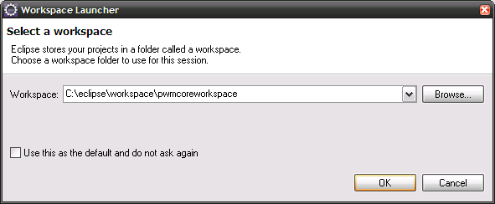

Click OK to open the workspace. By default the Java perspective will be opened showing a window similar to the following figure:

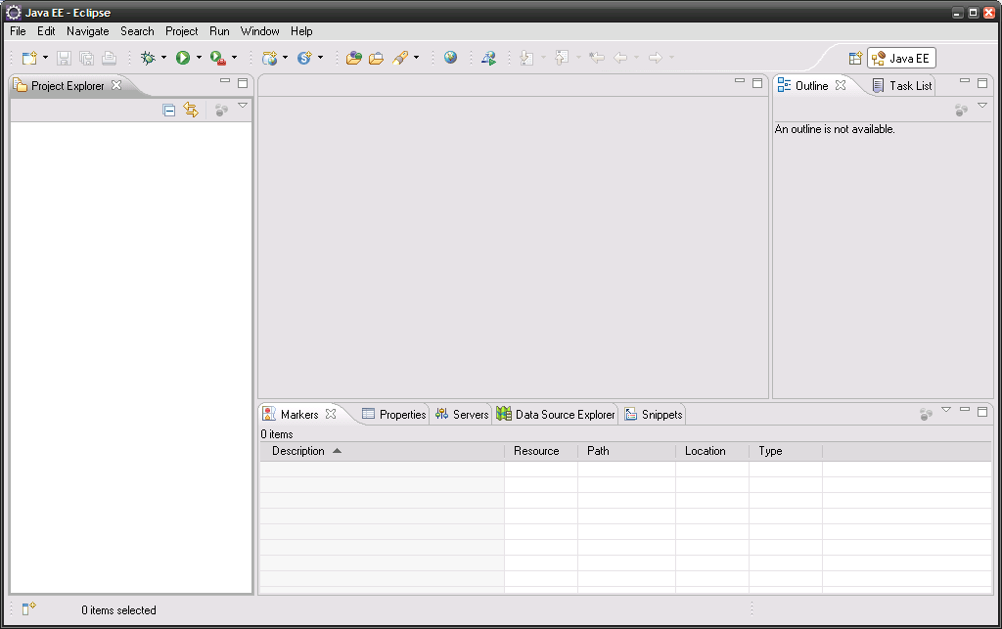

Installing the Bndtools plug-in
The Bndtools plug-in can be installed from the Eclipse Marketplace. Open the Eclipse Marketplace from the Help menu in Eclipse. In the Marketplace window search for ‘bnd’:

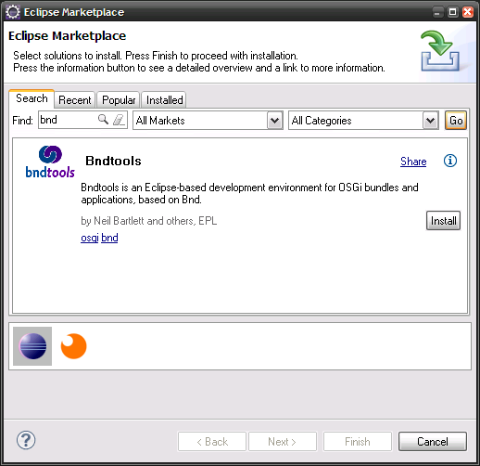
Install the Bndtools plug-in by clicking the Install button. You will be asked to confirm the installation of the requested feature and to agree with the license terms. There will be also a security warning because it contains ‘some unsigned content’. Ignore this warning and continue the installation. Finally you will be prompted to restart the workbench to work with Bndtools. After restart Eclipse is ready to work with source code that uses Bndtools artefacts like PowerMatcher Core.

Lotus Expeditor Client installation
The PowerMatcher Core source code requires that you have MicroBroker libraries installed on your system. MicroBroker is part of IBM Lotus Expeditor Client a commercial product that requires a license. Install Lotus Expeditor and accept the default installation paths. This is necessary because in a following step you will import a user library definition that will refer to this installation path. If you choose to use a different installation path you will need to update manually the user library definition in the Eclipse Preferences.

After installation the following libraries will have been installed:

- com.ibm.micro-3.0.2.jar (com.ibm.micro_3.0.3.0-20110708.jar)
- com.ibm.micro.admin-3.0.3 (com.ibm.micro.admin_3.0.3.0-20110708.jar)
- com.ibm.micro.client-3.0.2 (com.ibm.micro.client_3.0.3.0-20110708.jar)
- com.ibm.mqttclient-3.0.2 (com.ibm.mqttclient_3.0.3.0-20110708.jar)
- com.ibm.micro.utils-3.0.2 (com.ibm.micro.utils_3.0.3.0-20110708.jar)
- com.ibm.micro.utils.extended-3.0.2 (com.ibm.micro.utils.extended_3.0.3.0-20110708.jar).

For installation of Lotus Expeditor Client version 6.2.3 start the setupwin32.exe in the ‘desktop’ folder of the installation CD. Accept the default installation path and click next.

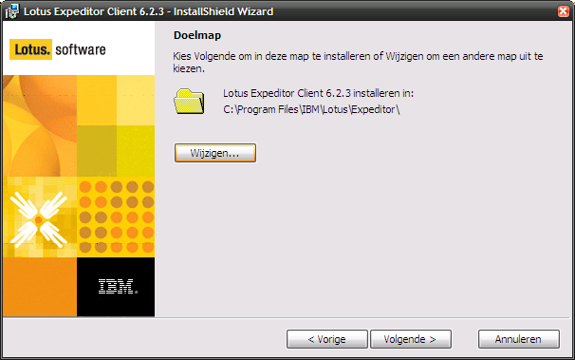
Figure 4 Lotus Expeditor Client installation wizard start screen.

Accept in the next screen the defaults (only install Expeditor Client) and click next.

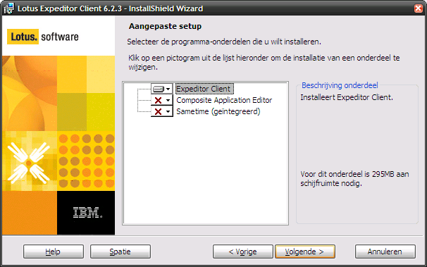
Figure 5 Lotus Expeditor Client installation wizard screen for changing setup defaults.

Finally click Install to start the installation.

The library files for MicroBroker can be found after installation of Lotus Expeditor Client in the following directory:

C:\Program Files\IBM\Lotus\Expeditor\rcp\eclipse\plugins

The Lotus Expeditor Client installation also includes an IBM JRE which can be found in directory:

C:\Program Files\IBM\Lotus\Expeditor\rcp\eclipse\plugins\com.ibm.rcp.j2se.win32.x86_1.6.0.20110714a-201108151128

Retrieving the source code

The source code of PowerMatcher Core is delivered as an Eclipse project archive compressed in ZIP format. Download the zip file using sftp from the server using the following data:

Hostname | <todo>
IP address | <todo>
Port | 22 (sftp)
Username | <todo>
Directory | /opt/ibm-mxv/source
File name | pwmcore_source.zip

Unzip the file to a directory and remember the location for the next steps.

IDE Setup

Start Eclipse and create a workspace named for example ‘pwmcoreworkspace’.

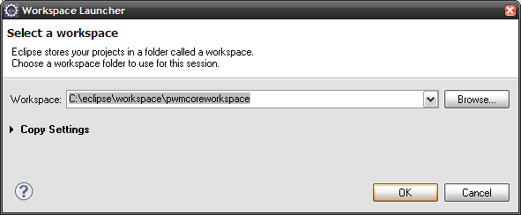

Change in the Preferences (from the Window menu) the JRE settings. Add the JDK that you installed in the previous step. Select the checkbox to make it the default JRE:

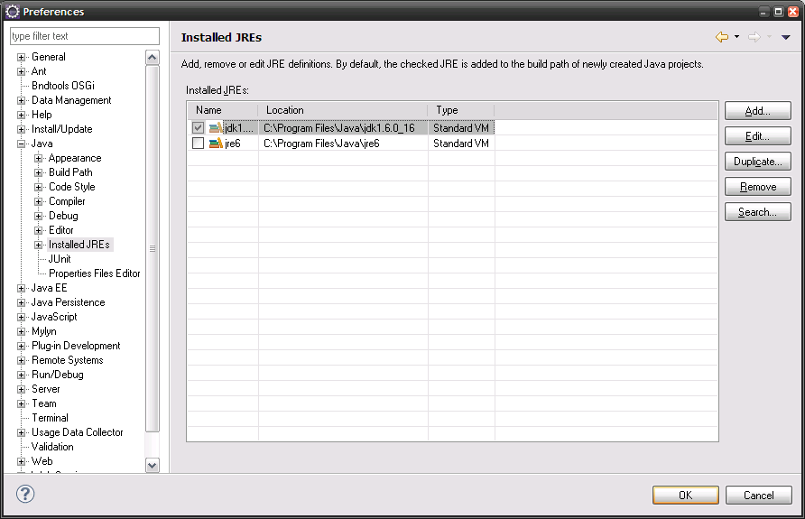

Open the Bndtools perspective (). When you open this for the first time the Bndtools will launch a Wizard to create a configuration project named ‘cnf’ to store its local bundle repository and build settings. Select ‘Create a configuration project’ and click Next.

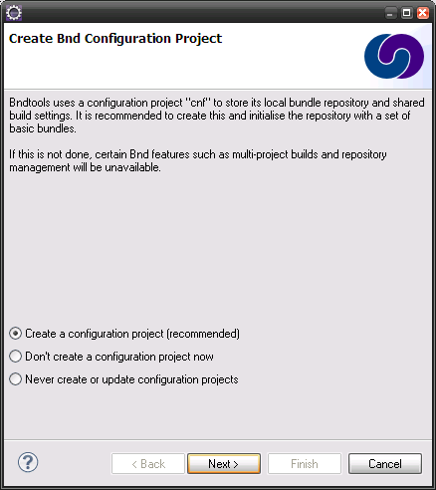
Figure 6 Bndtools wizard for creating a configuration project named ‘cnf’.

In the next screen select the ‘Standard Configuration’ template and click Finish.

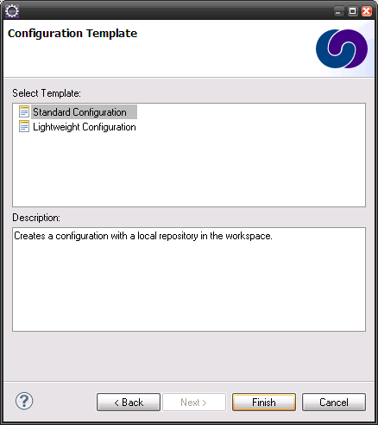
Figure 7 Select the Stand Configuration template for the 'cnf' project.

Bndtools will create ‘cnf’ project and add a set of libraries that are common in developing OSGi components:
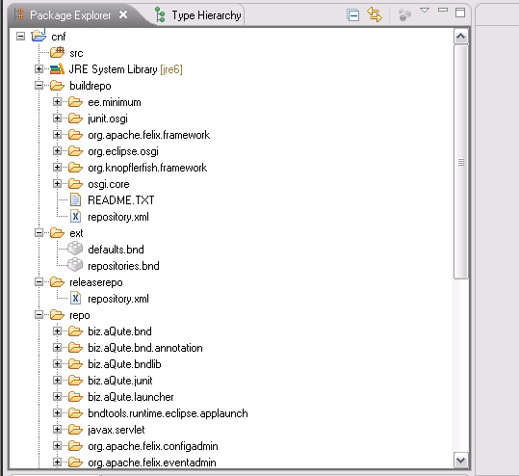
Figure 8 The 'cnf' project created by Bndtools prefilled with common bundles.

The MicroBroker bundles need to be added to the Local repository. In the Bndtools perspective navigate to the Repositories view and select Local repository. Click the icon of the ‘Add bundles to repository’ and add the jar files listed in 6.4:

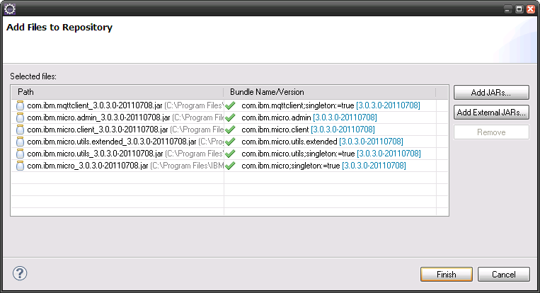
Figure 9 Add the MicroBroker jar files to the Bndtools repository.
Add also the following bundles to the Local repository:

Function | JAR file
Base 64 | org.apache.commons.codec-1.6.0.jar
Logging | slf4j.api-1.6.4.jar
Logging | slf4j.simple-1.6.4.jar
MQTT client | org.eclipse.paho.client.mqttv3-1.0.0.jar
MicroBroker (optional) | com.ibm.micro.admin_3.0.3.0
MicroBroker (optional) | com.ibm.micro.client_3.0.3.0
MicroBroker (optional) | com.ibm.micro.utils_3.0.3.0
MicroBroker (optional) | com.ibm.micro_3.0.3.0
MicroBroker (optional) | com.ibm.mqttclient_3.0.3.0
MicroBroker (optional) | com.ibm.mqttclient-3.0.3.jar

Importing the sources

Before the sources can be imported a ‘user library’ need for MicroBroker needs to be created. The user library settings are stored in a file and can be imported via the Eclipse Preferences window:

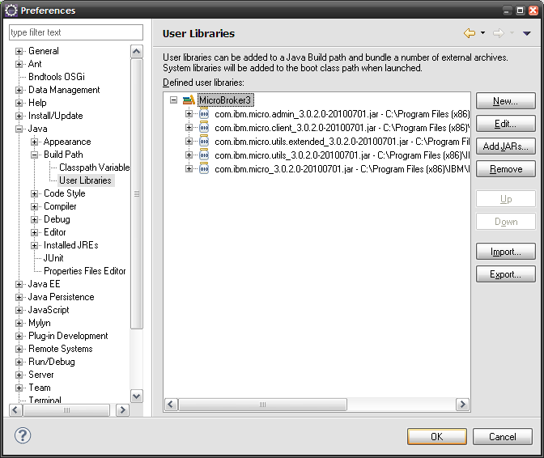

The user library file for the MicroBroker libraries is located in the com.ibm.matrixv.resource.core project in the subfolder ‘userlibraries’. The name is named ‘MicroBroker3.userlibraries. The import will create the MicroBroker3 user library that references the MicroBroker library files in the Lotus Expeditor installation directory. If you do not have this product installed you need to do this first. Click on the ‘Import…’ button in the User Libraries section in the Preferences window.

The projects can now be imported into the workspace. First switch off the automatic build option by de-selecting ‘Build automatically…’ in the Project menu. Then use the Import… wizard and select ‘Import existing projects into workspace’ and point the wizard to the folder where you exported the project archive file. Select all projects and check ‘Copy projects into workspace’ and import the projects by clicking the Finish button.

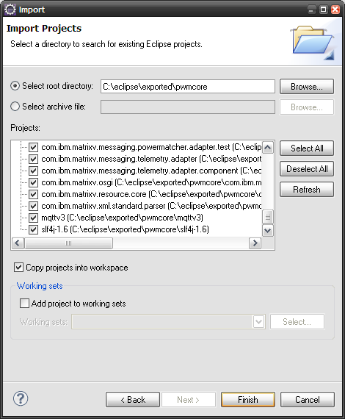

After the import completed restart the workbench (File -> Restart). The cnf repository cache of BND tools will now be cleared. From the message bar at the bottom of the window you can see when this task is running. If the task is completed check the ‘Build automatically…’ option or hit Ctrl-B (i.e. Build All). All projects should now compile successfully.

Code style and formatting preferences
Common coding standards are enforced by an Eclipse ‘style and formatting preferences’ file that has been designed for the project. Apply this style when you create new projects or modify existing ones.

You can import the preferences from:

/com.ibm.matrixv.doc/matrixv-eclipse-preferences.epf

The style and profile definitions in the epf file can also be viewed in a more readable format in the following two files:

/com.ibm.matrixv.doc/matrixv-eclipse-style-profile.xml
/com.ibm.matrixv.doc/matrixv-eclipse-formatter-profile.xml

In Eclipse or Rational Application Developer, open the Import Wizard (File->Import…) and choose in the category ‘General’ the ‘Preferences’ item. The Import Preferences Wizard will open. Browse to the .epf file in the com.ibm.matrixv.doc project in your workspace and click Finish. The code style and formatting preferences are now active.

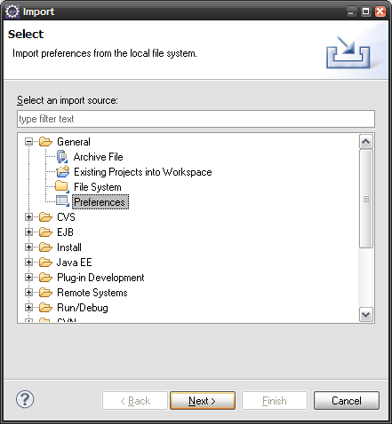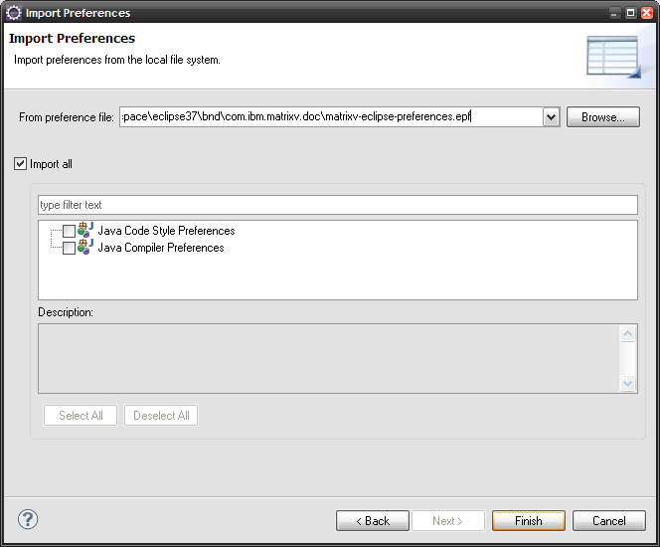
Figure 10 Eclipse preferences import wizard.

The style and formatting preferences can be applied to your code by selecting your projects and choosing Source->Clean up… (via the menu bar or context menu). A Clean Up wizard will popup which will guide you through the reformatting process. You can preview the proposed changes, but it is preferred that you accept all by clicking the Finish button.

NOTE: In Eclipse Java EE IDE for Web Developers (Version: Indigo Service Release 1, Build id: 20110916-0149) we noticed a bug. Although the MatrixV profile from the imported property files was automatically selected as the current profile, the formatting during a Clean Up did not work as defined in the profile.

We found a work-around by changing the Active Profile to the Eclipse built-in version in the Clean Up and Formatter preferences (Preferences->Code Style->Clean Up/Formatter). Then save the settings with the OK and change it back again to the MatrixV profile. The Clean Up and Formatting should now work fine.

Launching the application from the workbench
This paragraph describes how to run a PowerMatcher application from the development workbench in Eclipse. There will be two options: running a stand-alone application and running it within OSGi.

Run as a stand-alone application
The stand-alone application be simply run from the workbench using the Run icon in the toolbar. If you select the expand button next to it, you will see the ‘Matrix-V Main’ option. This is a link the launch configuration that you find in the com.ibm.matrixv.main project. It is also possible to launch the application from its context menu.

The application will use the agent_config.properties file in that same project. Modify it to customize you own PowerMatcher Core application.

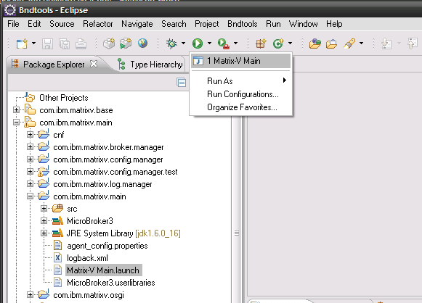

Run as an OSGi application
A PowerMatcher application running in the OSGi runtime environment can be started from a ‘bndrun’ file. In the project com.ibm.matrixv.osgi you can find two example run files. These are examples how you can run a PowerMatcher Core application within OSGi:

- Matrix-V Main on Equinox:
Running the application from this bnd run configuration file will start an Equinox OSGi runtime with the PowerMatcher Core bundles deployed. Since there are no configurations created there will be no active components. You can create the configurations manually using the Apache Felix Web Console as described in section 3.2.
- Matrix-V Main on pwm-local:
This bnd run configuration will start an Equinox OSGi runtime with some active components since it reads an XML configuration from the conf-local directory.

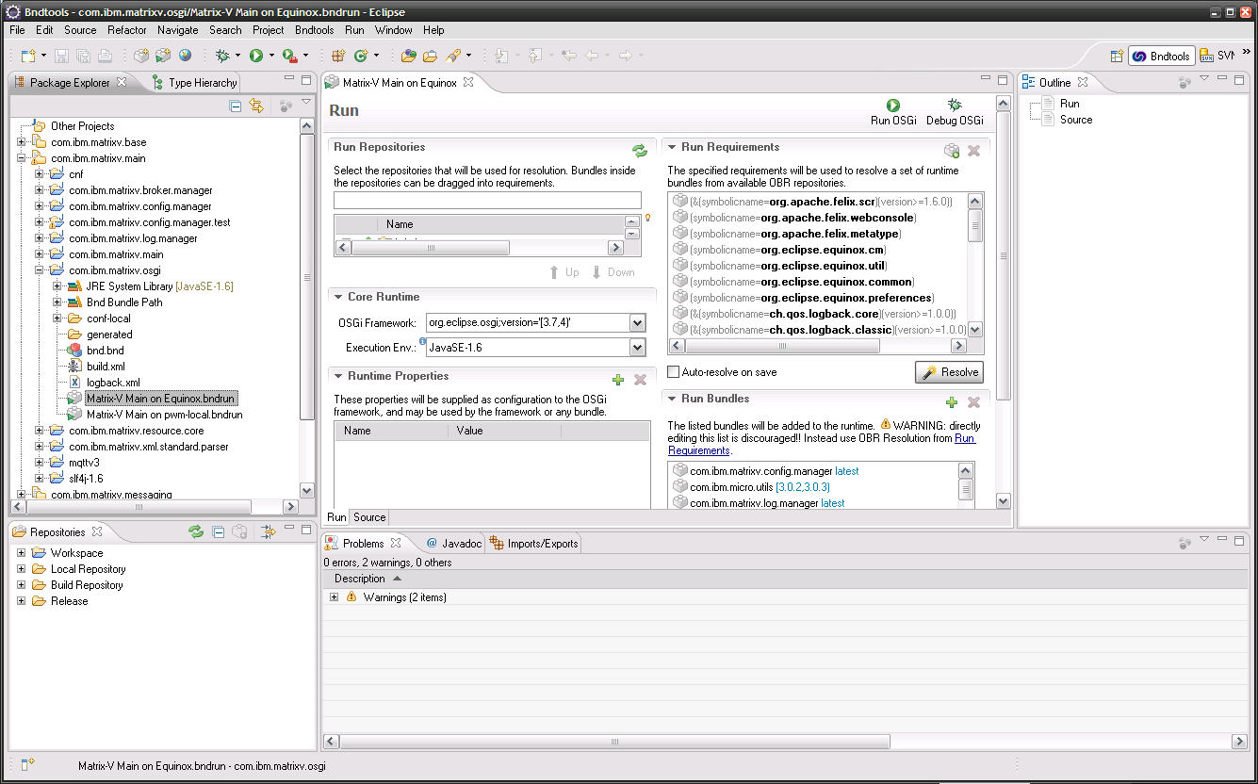

Building a PowerMatcher application

Build the stand-alone application
Make sure the source code is compiled by verifying if the option ‘Build Automatically’ is checked in the Project menu. If not check the option and verify the compilation progress in the status bar at the bottom of the window.

In the ‘Package Explorer’ view on the left unfold the com.ibm.matrixv.core item (click ‘+’) and do the same for the com.ibm.matrixv.demoapp project, then ‘src’ and then the com.ibm.matrixv.demoapp package until you see the Main.java source file.

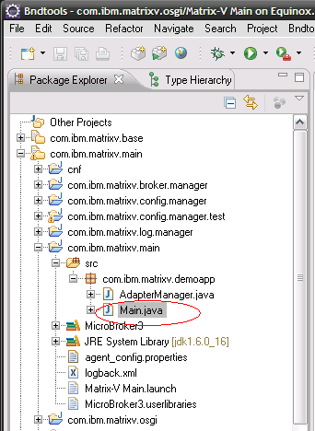

Select the Main.java source file. From the File menu select Export… menu option. The Export dialog will appear. Select the item Java->Runnable JAR and hit next:
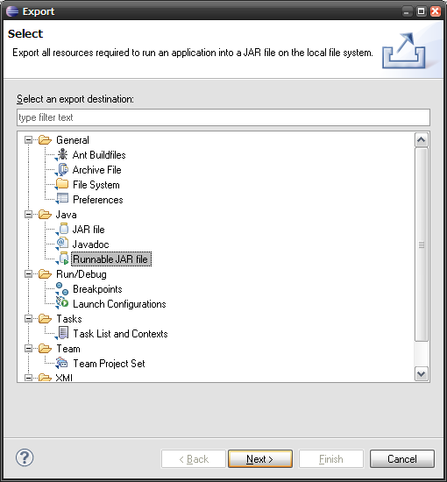

The page ‘Runnable JAR file export’ will appear. Complete the fields like the following figure:

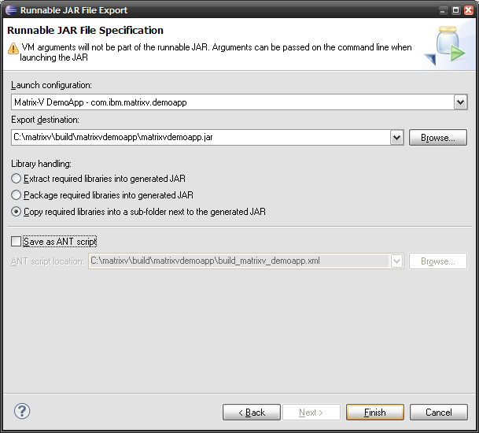

Note that the export destination direction can be changed. In this example we use the build directory C:\matrixv\build\matrixvdemoapp. The option ‘Copy required libraries into a sub-folder next to the generated JAR’ will create a matrixdemoapp_lib directory containing the required libraries.

The application needs also the logback.xml and the agent_config.properties. Copy these files from the com.ibm.matrixv.main project to the build directory.

Build the PowerMatcher Core OSGi bundle jars
If you run the PowerMatcher Core OSGi application from the workbench it will use the bundle jars located in the ‘generated’ directory of the projects. Building the bundle jars for deployment, which will not include the source code, is done via the build.xml file in the ‘com.ibm.matrixv.osgi’ project. This build script will invoke the build.xml script in the ‘cnf’ project with the Ant target ‘build’.

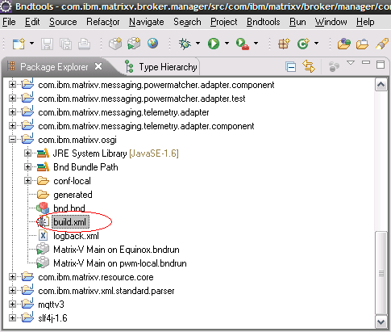
Figure 11 Build all Core bundles with the build.xml script in project 'com.ibm.matrixv.osgi'.

You can start the build by selecting the build.xml file en choosing Run As > ANT build. Individual bundles can be built (or released etc., depending on the selected Ant build target) via Run As > Ant Build on the build.xml in a bnd project.

Bndtools has also an option to include sources in the generated bundle jar:

-sources true|false

The sources are included under OSGI-OPT in the generated bundle jar. This option is true in the defaults generated by Bndtools in /cnf/ext/defaults.bnd. The default can be changed in /cnf/ext/defaults.bnd or can be overridden in /cnf/build.bnd.
Note: Make sure you do a clean all to force a rebuild of the bundles after changing any of the defaults.

Appendix A: PowerMatcher Components

Core components
This section describes the core components, their configuration properties and the dependencies.

Auctioneer
The auctioneer component creates an auctioneer instance, which will receive all the bids of the other agents as a single bid or as an aggregate bid via one or more concentrators. It is responsible for defining and sending the market basis and calculating the equilibrium based on the bids from the different agents in the topology. This equilibrium is communicated to the agents down the hierarchy in the form of price update messages.

Component: Auctioneer |  |  |  | Type: factory
Class: com.ibm.matrixv.agent.powermatcher.auctioneer.Auctioneer
Dependencies:
Matcher Adapter (com.ibm.matrixv.messaging.powermatcher.adapter.MatcherProtocolAdapter),
Market Basis Adapter ( com.ibm.matrixv.messaging.powermatcher.adapter.MatcherProtocolAdapter),
MQTT Messaging Connection (com.ibm.matrixv.messaging.mqttv3.Mqttv3Connection or com.ibm.matrixv.messaging.mqttv5.Mqttv5Connection)
Property | Type | Req. | Default | Description
id | String | Y | - | Component instance id e.g. ‘auctioneer1’
cluster.id | String | N | MatrixV | Cluster id or sometimes also referred to as namespace id.
enabled | boolean | N | true | If true component will not be activated when all dependencies are resolved. Otherwise if false it will never be activated.
update.interval | int | N | 30 | Number of seconds of message interval.
bid.expiration.time | int | N | 300 | Number of seconds before a received update bid from client agents expires.

Concentrator
The concentrator is a factory component from which several instances can be created. The concentrator receives the bids from the agents and forwards this in an aggregate bid up in the hierarchy to another concentrator or to the auctioneer directly. It will receive price update messages from the auctioneer and forward them to its connected agents.
Component: Concentrator |  |  |  | Type: factory
Class: com.ibm.matrixv.powermatcher.concentrator.Concentrator
Dependencies:
Matcher Adapter (com.ibm.matrixv.messaging.powermatcher.adapter.MatcherProtocolAdapter),
Agent Adapter (com.ibm.matrixv.messaging.powermatcher.adapter.AgentProtocolAdapter)
MQTT Messaging Connection (com.ibm.matrixv.messaging.mqttv3.Mqttv3Connection or com.ibm.matrixv.messaging.mqttv5.Mqttv5Connection)
Property | Type | Req. | Default | Description
id | String | Y | - | Component instance id e.g. ‘auctioneer1’
cluster.id | String | N | MatrixV | Cluster id or sometimes also referred to as namespace id.
enabled | boolean | N | true | If true component will not be activated when all dependencies are resolved. Otherwise if false it will never be activated.
update.interval | int | N | 30 | Number of seconds of message interval.
bid.expiration.time | int | N | 300 | Number of seconds before a received update bid from client agents expires.

Clipping concentrator
A special type of concentrator component, the Clipping Concentrator, can limit the power consumption of its group to a certain configurable level.

Component: Clipping Concentrator |  |  |  | Type: factory
Class: com.ibm.matrixv.powermatcher.concentrator.ClippingConcentrator
Dependencies:
Matcher Adapter (com.ibm.matrixv.messaging.powermatcher.adapter.MatcherProtocolAdapter),
Agent Adapter (com.ibm.matrixv.messaging.powermatcher.adapter.AgentProtocolAdapter)
MQTT Messaging Connection (com.ibm.matrixv.messaging.mqttv3.Mqttv3Connection or com.ibm.matrixv.messaging.mqttv5.Mqttv5Connection)
Property | Type | Req. | Default | Description
id | String | Y | - | Component instance id e.g. ‘auctioneer1’
cluster.id | String | N | MatrixV | Cluster id or sometimes also referred to as namespace id.
enabled | boolean | N | true | If true component will not be activated when all dependencies are resolved. Otherwise if false it will never be activated.
update.interval | int | N | 30 | Number of seconds of message interval.
bid.expiration.time | int | N | 300 | Number of seconds before a received update bid from client agents expires.
peak.shaving.enabled | boolean | N | false | Defines if peak shaving is enabled
power.lower.limit | double | N | - | Lower limit in Watt, required if peak shaving enabled.
power.upper.limit | double | N | - | Upper limit in Watt, required if peak shaving enabled.

CSV Logging agent
The CSV Logging Agent subscribes to status, telemetry, price update and bid log messages and stores them in a comma separated file (csv-file).

Component: CSV Logging Agent |  |  |  | Type: factory
Class: com.ibm.matrixv.agent.powermatcher.logging.CSVLoggingAgent
Dependencies:
Telemetry Adapter (com.ibm.matrixv.messaging.telemetry.adapter.TelemetryAdapter),
Log Listener Adapter (com.ibm.matrixv.messaging.powermatcher.adapter.LogListenerAdapter)
MQTT Messaging Connection (com.ibm.matrixv.messaging.mqttv3.Mqttv3Connection or com.ibm.matrixv.messaging.mqttv5.Mqttv5Connection)
Property | Type | Req. | Default |  | Description
id | String | Y | - |  | Component instance id e.g. ‘auctioneer1’
cluster.id | String | N | MatrixV |  | Cluster id or sometimes also referred to as namespace id.
enabled | boolean | N | true |  | If true component will not be activated when all dependencies are resolved. Otherwise if false it will never be activated.
update.interval | int | N | 30 |  | Number of seconds of message interval.
measurement.logging.pattern | String | N | 'measurement_log_'yyyyMMdd'.csv' |  | Define the measurement logging pattern.
powermatcher.bid.logging.pattern | String | N | 'pwm_bid_log_'yyyyMMdd'.csv' |  | Define the PowerMatcher bid logging pattern.
powermatcher.price.logging.pattern | String | N | 'pwm_price_log_'yyyyMMdd'.csv' |  | Define the PowerMatcher bid logging pattern.
status.logging.pattern | String | N | 'status_log_'yyyyMMdd'.csv' |  | Define the status logging pattern.
date.format | String | N | yyyy-MM-dd HH:mm:ss |  | Logging date format
list.separator | String | N | ; |  | Separator of logged data.
bid.expiration.time | int | N | 300 |  | Number of seconds before a received update bid from an agents expires.

Objective agent
The Objective Agent component influences the market price and the power consumption to a configurable value.

Component: Objective Agent |  |  |  | Type: factory
Class: com.ibm.matrixv.agent.powermatcher.objective.ObjectiveAgent
Dependencies:
Matcher Adapter (com.ibm.matrixv.messaging.powermatcher.adapter.MatcherProtocolAdapter),
Agent Adapter (com.ibm.matrixv.messaging.powermatcher.adapter.AgentProtocolAdapter),
Telemetry Adapter (com.ibm.matrixv.messaging.telemetry.adapter.TelemetryAdapter),
MQTT Messaging Connection (com.ibm.matrixv.messaging.mqttv3.Mqttv3Connection or com.ibm.matrixv.messaging.mqttv5.Mqttv5Connection)
Property | Type | Req. | Default | Description
id | String | Y | - | Component instance id e.g. ‘auctioneer1’
cluster.id | String | N | MatrixV | Cluster id or sometimes also referred to as namespace id.
enabled | boolean | N | true | If true component will not be activated when all dependencies are resolved. Otherwise if false it will never be activated.
update.interval | int | N | 30 | Number of seconds of message interval.
objective.bid | String | Y | (0\\,0.0);(0\\,0.0) | Defines the objective bid. Format is a sequence of pairs of price/power points (int: price, double: power).
bid.expiration.time | int | N | 300 | Number of seconds before a received update bid from client agents expires.
Setting the ‘objective.bid’ property is required because the default bid will produce exceptions.

Test agent
The Test Agent is an example agent for testing and learning purposes. It receives prices updates from the matcher and sends update bids based on the configured property values.

Component: Test Agent |  |  |  | Type: factory
Class: com.ibm.matrixv.agent.powermatcher.framework.test.TestAgent
Dependencies:
Agent Adapter (com.ibm.matrixv.messaging.powermatcher.adapter.AgentProtocolAdapter),
Telemetry Adapter (com.ibm.matrixv.messaging.telemetry.adapter.TelemetryAdapter),
MQTT Messaging Connection (com.ibm.matrixv.messaging.mqttv3.Mqttv3Connection or com.ibm.matrixv.messaging.mqttv5.Mqttv5Connection)
Property | Type | Req. | Default | Description
id | String | Y | - | Component instance id e.g. ‘auctioneer1’
cluster.id | String | N | MatrixV | Cluster id or sometimes also referred to as namespace id.
enabled | boolean | N | true | If true component will not be activated when all dependencies are resolved. Otherwise if false it will never be activated.
update.interval | int | N | 30 | Number of seconds of message interval.
maximum.power | double | N | 1000 | Defines the maximum power the agent can use.
minimum.power | double | N | 1000 | Defines the minimum power the agent can use.
maximum.price | int | N | 120 | Defines the maximum bid price of the update bids the agent sends.
minimum.price | int | N | 0 | Defines the minimum bid price of the update bids the agent sends.
steps | int | N | 12 | Number of price steps (price variations) in the update bids between the minimum price and maximum price.

Broker Manager
The Broker Manager component starts a broker.

Component: Broker Manager |  |  |  | Type: factory
Class: com.ibm.matrixv.broker.manager.BrokerManager
Dependencies:
Microbroker libararies
Property | Type | Req. | Default | Description
broker.name | String | N | MicroBroker | MicroBroker instance name. A directory with the same name will be created to store MicroBroker data.
microbroker.dir | String | N | MatrixV | Directory where the MicroBroker data directory will be created.
microbroker.maxMessageSize | int | N | 100 | Maximum message size that is allowed on the created MQTT bus.
microbroker.maxNumberOfClients | int | N | -1 | Maximum number of clients (-1 is no limit).
microbroker.numberOfLogFilesToKeep | int | N | 10 | Maximum number of log files to keep.
microbroker.persistence | int | N | 0 | Persist the messages on topics and queues.
microbroker.port | int | N | 1883 | MicroBroker port.
microbroker.queueSize | int | N | 0 | Message queue size.
microbroker.waitTimeout | long | N | 10000 | Timeout.

Security is enabled by default if JAAS is supported, and anonymous connections are permitted by default. Local authentication requires customization of the default 'acl'-file that is generated when a new broker is started and requires a custom JAAS authentication module (the default MicroBroker JAAS module must be configured somehow, but this does not appear to be documented.

Micro broker bridge
The MicroBroker bridge or Pipe connects two MQTT ESB’s.

Component: Broker Manager |  |  |  | Type: factory
Class: com.ibm.matrixv.broker.manager.Pipe
Dependencies:
Microbroker libararies
Property | Type | Req. | Default |  | Description
id | String | Y | - |  | Component instance id e.g. ‘auctioneer1’
cluster.id | String | N | MatrixV |  | Cluster id or sometimes also referred to as namespace id.
pipe.name | String | N | - |  | Maximum message size that is allowed on the created MQTT bus.
in.topics | String | N | PowerMatcher/${cluster.id}/+/UpdatePriceInfo,Configuration/Update/+ |  | Defines allowed incoming (from the remote host) messages.
in.target.topic | String | N | 10 |  | If specified incoming topics will be put on this topic on the (local) host.
out.topics | String | N | PowerMatcher/${cluster.id}/+/+/UpdateBid\\,PowerMatcher/${cluster.id}/+/+/Log\\,CPSS/#\\,Status/# |  | Defines allowed outgoing (to the remote host) messages.
out.target.topic | String | N | 1883 |  | If specified outgoing messages will be put on this topic on the remote host.
keep.alive.secs | short | N | 60 |  | Defines interval for the ‘keep alive’ signal.
remote.host | long | Y | - |  | Hostname of target MQTT bus.
remote.port | int | N | 1883 |  | Port number of target MQTT bus.
remote.secure | boolean | N | false |  | Enforce secure connection.
remote.username | String | N | - |  | Remote user for authentication secure connection.
remote.password | String | N | - |  | Remote password for authentication secure connection.
notification.enabled | boolean | N | true |  | Send notification messages.
host.name | String | N | - |  | Host name of Bridge start MQTT bus.
component.name | String | N | - |  | Component name.
notification.topic | String | N | Status/Bridge |  | Topic name of notification message.
notification.connected.message | String | N | CONNECTED\\,I\\,${cluster.id}\\,${id}\\,${pipe.name}\\,${component.name}\\,${host.name} |  | Format of notification message.
notification.cleandisconnected.message | String | N | CLEANDISCONNECTED\\,I\\,${cluster.id}\\,${id}\\,${pipe.name}\\,${component.name}\\,${host.name} |  | Format of clean disconnect message.
notification.disconnected.message | String | N | DISCONNECTED\\,W\\,${cluster.id}\\,${id}\\,${pipe.name}\\,${component.name}\\,${host.name} |  | Format of disconnect message caused by an exception.

Component Adapters
This section describes the available adapters for PowerMatcher Core components.

Market Basis Adapter
The MarketBasis Adapter defines the market basis for the bids in the PowerMatcher cluster. The adapter should be connected to an auctioneer.

Component: Market Basis Adapter |  |  |  | Type: factory
Class: com.ibm.matrixv.agent.powermatcher.marketbasis.adapter.MarketBasisAdapter
Dependencies: -
Property | Type | Req. | Default | Description
id | String | Y | - | Component instance id e.g. ‘auctioneer1’ to which the adapter should be linked.
cluster.id | String | N | MatrixV | Cluster id or sometimes also referred to as namespace id.
commodity | String | N | electricity | Commodity of this PowerMatcher cluster, for example electricity.
currency | String | N | EUR | Market currency.
market.ref | int | N | 0 | Initial value Market Basis sequence number (market ref) referenced by the update bids of the agents.
minimum.price | double | N | -127 | Defines the lower limit of the normalized price range.
maximum.price | double | N | 127 | Defines the upper limit of the normalized price range.
price.steps | int | N | 255 | Defines the number of price steps within the normalized price range.
significance | int | N | 0 | Defines the significance of the agent price bids.

Agent Adapter

The Agent Adapter is a messaging protocol adapter for the Agent interface of a PowerMatcher component. It enables the agent to send bid update messages and log messages, receive price update messages, configure the messaging protocol to be used.

The adapter is normally used by every (device) agent and concentrator.

Component: Agent Adapter |  |  |  | Type: factory
Class: com.ibm.matrixv.messaging.powermatcher.adapter.AgentProtocolAdapter
Dependencies: -
Property | Type | Req. | Default | Description
id | String | Y | - | Component instance id e.g. ‘auctioneer1’ to which the adapter should be linked.
cluster.id | String | N | MatrixV | Cluster id or sometimes also referred to as namespace id.
connector.id | String | N | <id> | Id of the (MQTT) connection adapter. Default is the same as the id.
matcher.id | String | N | root | Id of the matcher to be used in the topic name where the update bids are published.
messaging.protocol | String | Y | INTERNAL_v1 | Protocol to be used. Possible values: { "INTERNAL_v1", "HAN_rev6" }
bid.topic.suffix | String | N | UpdateBid | Update bid topic name suffix. Agent will send update bid messages to this topic.
price.info.topic.suffix | String | N | UpdatePriceInfo | Price Info topic name suffix. Agent will subscribe to this topic for price info messages from the matcher.
log.topic.suffix | String | N | Log | Log topic name suffix. Agent will send log messages to this topic.
agent.bid.log.level | String | N | NO_LOGGING | Log level for sent update bid messages. Values: { "NO_LOGGING", "PARTIAL_LOGGING", "FULL_LOGGING" }
agent.price.log.level | String | N | NO_LOGGING | Log level for received price update messages. { "NO_LOGGING", "FULL_LOGGING" }

A component extended with the Agent Adapter registers the connector services it provides under connectorId. If the connectorId is not configured explicitly, by default the connectorId of a component is the same as the id of the component.

This is fine for most situations. Normally the id of the Connection component is the same as that of the Matcher and the Agent Adapter of, for example, a PowerMatcher Concentrator component.
In this situation one Connection, for example an MQTT client connection, is shared between Matcher and Agent adapter.

However, if you want to use different Connections for the Matcher and Agent adapter (for example connecting to different brokers), then each Connection will have its own distinct id. In that case the Matcher and Agent adapter explicitly specify the id of the Connection that they want to connect to using the connectorId property

Matcher Adapter
Messaging protocol adapter for the Matcher interface of a PowerMatcher component. This adapter enables a matcher to send aggregated bid updates to a parent matcher, receive bid updates from agents, send log messages and customize the messaging protocol.

Component: Matcher Adapter |  |  |  | Type: factory
Class: com.ibm.matrixv.messaging.powermatcher.adapter.MatcherProtocolAdapter
Dependencies: -
Property | Type | Req. | Default | Description
id | String | Y | - | Component instance id e.g. ‘auctioneer1’ to which the adapter should be linked.
cluster.id | String | N | MatrixV | Cluster id or sometimes also referred to as namespace id.
connector.id | String | N | <id> | Id of the (MQTT) connection adapter. Default is the same as the id.
matcher_listener_id | String | N | <id> | Id of the matcher to be used in the topic name construction where the update bids are published by the agents and the matcher is subscribed to.
messaging.protocol | String | Y | INTERNAL_v1 | Protocol to be used. Possible values: { “INTERNAL_v1”, “HAN_rev6” }
bid.topic.suffix | String | N | UpdateBid | Update bid topic name suffix. Agents will send update bid messages to this topic and the matcher will process them.
price.info.topic.suffix | String | N | UpdatePriceInfo | Price Info topic name suffix. The matcher will subscribe to this topic for price info messages from the parent matcher.
log.topic.suffix | String | N | Log | Log topic name suffix. Agent will send log messages to this topic.
matcher.agent.bid.log.level | String | N | FULL_LOGGING | Log level for received update bid messages. Values: { "NO_LOGGING", "PARTIAL_LOGGING", "FULL_LOGGING" }
matcher.aggregated.bid.log.level | String | N | NO_LOGGING | Log level for sent aggregated update bid messages. Values: { "NO_LOGGING", "PARTIAL_LOGGING", "FULL_LOGGING" }
matcher.price.log.level | String | N | FULL_LOGGING | Log level for received price update messages. { "NO_LOGGING", "FULL_LOGGING" }

See also comment on the ‘connector.id’ property in section 7.2.6 Log Listener adapter which also applies to the Matcher Adapter.

The Objective Agent also uses this adapter to receive the same bids as the Auctioneer does. Like the Auctioneer it processes the bids to calculate the market price, however unlike the Auctioneer it does not send an price update info message but an sends update bid to the Auctioneer influence the market price to the configured objective.

MQTT v3 connection adapter
The MQTT v3 connection adapter is a messaging connection for messaging protocol adapters. The adapter implements the MQTT version 3 protocol. An MQTTv3 Messaging Connection can be shared between messaging protocol adapters. It is recommended, though, that each component (auctioneer, matcher, agent etc.) has its own connection adapter.

Component: MQTT v3 connection adapter |  |  |  | Type: factory
Class: com.ibm.matrixv.messaging.mqttv3.Mqttv3Connection
Dependencies: -
Property | Type | Req. | Default |  | Description
id | String | Y | - |  | Component instance id e.g. ‘auctioneer1’
cluster.id | String | N | MatrixV |  | Cluster id or sometimes also referred to as namespace id.
broker.uri | String | N | tcp://localhost:1883 |  | Broker URI.
broker.username | String | N | - |  | Broker username. Only applicable when broker security is enabled.
broker.password | String | N | 10 |  | Broker password. Only applicable when broker security is enabled.
notification.enabled | boolean | N | false |  | Send notification messages.
hostname | String | N | - |  | Hostname of the MQTT client.
component.name | String | N | - |  | Component name.
notification.topic | String | N | Status/Agent |  | Topic name notification messages.
notification.connected.message | String | N | CONNECTED\\,I\\,${cluster.id}\\,${id}\\,${component.name}\\,${component.name}\\,${host.name}1883 |  | Format of notification message.
notification.cleandisconnected.message | String | N | CLEANDISCONNECTED\\,W\\,${cluster.id}\\,${id}\\,${component.name}\\,${component.name}\\,${host.name} |  | Format of clean disconnect message.
notification.disconnected.message | String | N | DISCONNECTED\\,I\\,${cluster.id}\\,${id}\\,${component.name}\\,${component.name}\\,${host.name} |  | Format of disconnect message caused by an exception.
reconnect.interval | int | N | 10 |  | Retry interval to (re)connect.

MQTT v5 connection adapter
The MQTT v5 connection adapter is a messaging connection for messaging protocol adapters. The adapter implements the MQTT version 5 protocol. An MQTTv5 Messaging Connection can be shared between messaging protocol adapters. It is recommended, though, that each component (auctioneer, matcher, agent etc.) has its own connection adapter.

Component: MQTT v5 connection adapter |  |  |  | Type: factory
Class: com.ibm.matrixv.messaging.mqttv5.Mqttv5Connection
Dependencies: -
Property | Type | Req. | Default |  | Description
id | String | Y | - |  | Component instance id e.g. ‘auctioneer1’
cluster.id | String | N | MatrixV |  | Cluster id or sometimes also referred to as namespace id.
broker.uri | String | N | local://MicroBroker |  | Broker URI.
broker.username | String | N | - |  | Broker username. Only applicable when broker security is enabled.
broker.password | String | N | 10 |  | Broker password. Only applicable when broker security is enabled.
notification.enabled | boolean | N | false |  | Send notification messages.
hostname | String | N | - |  | Hostname of the MQTT client.
component.name | String | N | - |  | Component name.
notification.topic | String | N | Status/Agent |  | Topic name notification messages.
notification.connected.message | String | N | CONNECTED\\,I\\,${cluster.id}\\,${id}\\,${component.name}\\,${component.name}\\,${host.name}1883 |  | Format of notification message.
notification.cleandisconnected.message | String | N | CLEANDISCONNECTED\\,W\\,${cluster.id}\\,${id}\\,${component.name}\\,${component.name}\\,${host.name} |  | Format of clean disconnect message.
notification.disconnected.message | String | N | DISCONNECTED\\,I\\,${cluster.id}\\,${id}\\,${component.name}\\,${component.name}\\,${host.name} |  | Format of disconnect message caused by an exception.
reconnect.interval | int | N | 10 |  | Retry interval to (re)connect.

Log Listener adapter
The Log Listener Adapter is a messaging adapter for handling logging events from PowerMatcher components.

Component: Log Listener Adapter |  |  |  | Type: factory
Class: com.ibm.matrixv.messaging.powermatcher.adapter.LogListenerAdapter
Dependencies: -
Property | Type | Req. | Default | Description
id | String | Y | - | Component instance id e.g. ‘csvlogging1’ to which the adapter should be linked.
cluster.id | String | N | MatrixV | Cluster id or sometimes also referred to as namespace id.
connector.id | String | N | <id> | Id of the (MQTT) connection adapter. Default is the same as the id.
bid.topic.suffix | String | N | UpdateBid | Update bid topic name suffix. Agent will subscribe to topics with this suffix and listen for update bid log messages.
price.info.topic.suffix | String | N | UpdatePriceInfo | Price Info topic name suffix. Agent will subscribe to topics with this suffix and the log topic suffix for price info log messages.
log.topic.suffix | String | N | Log | Log topic name suffix.

See also comment on the ‘connector.id’ property in section 7.2.6 Log Listener adapter which also applies to the Log Listener Adapter.

Telemetry Adapter
The Telemetry Adapter is an adapter for sending and receiving telemetry data over the MQ Telemetry protocol.

Component: Telemetry Adapter |  |  |  | Type: factory
Class: com.ibm.matrixv.messaging.telemetry.adapter.TelemetryAdapter
Dependencies: -
Property | Type | Req. | Default | Description
id | String | Y | - | Component instance id e.g. ‘csvlogging1’ to which the adapter should be linked.
cluster.id | String | N | MatrixV | Cluster id or sometimes also referred to as namespace id.
connector.id | String | N | <id> | Id of the (MQTT) connection adapter. Default is the same as the id.
bid.topic.suffix | String | N | UpdateBid | Update bid topic name suffix. Agent will subscribe to topics with this suffix and listen for update bid messages.
price.info.topic.suffix | String | N | UpdatePriceInfo | Price Info topic name suffix. Agent will subscribe to topics with this suffix for price info messages.
log.topic.suffix | String | N | Log | Log topic name suffix. Agent will subscribe for log messages to topics with this suffix.

See also comment on the ‘connector.id’ property in section 7.2.6 Log Listener adapter which also applies to the Telemetry Adapter.

ConfigManager component
The ConfigManager component reads OSGi configuration specifications in XML format and invokes the ConfigAdmin service of OSGi to create, update or delete configuration objects. Configuration files can be located locally, on a remote (secure or non-secure) server location or from an http web service.

The component checks within a configurable interval if the configuration has been updated.

Component: Telemetry Adapter |  |  |  | Type: factory
Class: com.ibm.matrixv.config.manager.ConfigManager
Dependencies: -
Property | Type | Req. | Default | Description
id | String | Y | - | Component instance id e.g. ‘csvlogging1’ to which the adapter should be linked.
cluster.id | String | N | MatrixV | Cluster id or sometimes also referred to as namespace id.
node.id | String | Y | defaultnode | Id identifiying the OSGi runtime node.
configuration.data.url | String | Y | file:conf-local/default_config.xml | URL identifying the location of the XML configuration resource.
configuration.data.userid | String | N | - | User id for retrieving a secured XML configuration resource.
configuration.data.password | String | N | - | Password for retrieving a secured XML configuration resource.
update.interval | int | Y | 300 | Refresh interval seconds for refreshing the configuration.

Appendix B: OSGi runtime installation and setup
In order to run the PowerMatcher applications you need to set up an OSGi runtime environment. We use Pax-Runner simplify this task. Simply stated, Pax Runner is an OSGi framework launcher that supports the setup of different OSGi framework implementations like Apache Felix, Equinox and Knopflerfish. In this instruction we will use the Equinox implementation but will enhance the functionality by adding components from the Apache Felix implementation.

Pax Runner installation and setup
Follow the next steps to create a basic Pax Runner environment that will use the Equinox OSGi implementation:

- First download the Pax Runner from the OPS4J site [3]. You may download the assembly which already contains example run scripts for Windows and Unix or you can just download just the pax-runner-x.y.z.jar file (where x.y.z is the version number). The Pax-Runner version used in the project is version 1.7.6.

- Create a target directory which to store the Pax Runner distribution and the PowerMatcher bundles. In this document we assume the directory is C:\apache\pax-runner.

- In the Pax Runner target directory create the following directories:
Directory name | Purpose
required-bundles | Required non-PowerMatcher bundles. For example for logging, web console, administration and configuration
bundles | This will contain the application specific bundles.
conf | Directory for configuration files

- Copy the Pax Runner jar file to the target directory.

- Create a property file named ‘platform.properties’ in the Pax Runner target directory. This file will contain the start-up environment variables or system properties. In one of the next steps you will edit this file.
- In the Pax Runner directory Create a shell script named ‘run.sh’ for starting PaxRunner. For windows create a file named ‘run.bat’ that will contain the following:
call java -jar pax-runner-1.7.6.jar --platform=equinox --version=3.7.1 --ups --workingDirectory=. scan-dir:required-bundles scan-file:file:platform.properties
This will start Pax Runner using the Equinox OSGi implementation version 3.7.1 from the current directory as a working directory. The scan:dir and scan:file parameters direct the Pax Runner to load bundles or settings from a specific directory or file.
During start-up Pax-Runner will download the specified OSGi framework (.jar file), which requires a connection to the Internet. If this is not available, you first can download it from the Eclipse site using another machine that does have Internet access [4].

The Pax Runner setup is ready. You can start it using the run command script. It will start an OSGi environment with a web console. In the platform properties we specified the port number for the web console, this makes it accessible from:
http://localhost:8080/system/console

We have created now a base OSGi environment and we have to prepare it for running PowerMatcher based applications. Follow the steps described in the next sections.

Install the required bundles
A PowerMatcher application in OSGi requires a set of libraries. The required-bundles directory will contain all the non-project specific support libraries. The libraries are not delivered in the release but have to be acquired individually. Copy the jar libraries listed in Table 5 to this directory:

Function | JAR file | Description | Download
OSGi | osgi.cmpn-4.2.0.jar | OSGi Service Platform Service Compendium jar library. | See [5].
Eclipse Equinox OSGi implementation | org.eclipse.equinox.cm | Individual bundles that provide standalone OSGi specified services or add-on mechanisms. | See [4], choose build version then Add-on bundles and find specified jar.
Eclipse Equinox OSGi implementation | org.eclipse.equinox.common
Eclipse Equinox OSGi implementation | org.eclipse.equinox.log
Eclipse Equinox OSGi implementation | org.eclipse.equinox.preferences
Eclipse Equinox OSGi implementation | org.eclipse.equinox.util
Base 64 | org.apache.commons.codec | Encoders and decoders such as Base64 | See [6].
Apache Felix web console | org.apache.felix.dependencymanager | Apache Felix Dependency Manager | [7]. Select ‘Downloads’ link.
Apache Felix web console | org.apache.felix.webconsole-3.1.8.jar | Apache Felix Web Console | [7]. Select ‘Downloads’ link.
Apache Felix web console | org.apache.felix.http.jetty-2.2.0.jar | Apache Felix Http Service Jetty | [7]. Select ‘Downloads’ link.
Apache Felix web console | org.apache.felix.scr-1.6.0.jar | Apache Felix SCR (Declarative Services) | [7]. Select ‘Downloads’ link.
Apache Felix web console | org.apache.felix.metatype-1.0.4.jar | Apache Felix Metatype | [7]. Select ‘Downloads’ link.
Bnd libraries | biz.aQute.bndlib | Bnd base library. | See [8].
Bnd libraries | biz.aQute.junit | Bundle that provides junit and supports testing within the OSGi framework. | See [8].
Logging | slf4j.api-1.6.4.jar | Simple Logging Facade for Java (SLF4J) | See [9].
Logging | slf4j.simple-1.6.4.jar | Simple Logging Facade for Java (SLF4J) | See [9].
Logging | ch.qos.logback.classic | Logging framework. | See [10].
Logging | ch.qos.logback.core | Logging framework. | See [10].
MQTT client | org.eclipse.paho.client.mqttv3 | Open source implementation of messaging client using the MQTT version 3 protocol. | See [11]
MicroBroker (optional) | com.ibm.micro | IBM MicroBroker. Commercial MQTT broker implementation. Delivered with the IBM Lotus Expeditor product. | See [12] and paragraph 6.4.
MicroBroker (optional) | com.ibm.micro.admin |  | See [12] and paragraph 6.4.
MicroBroker (optional) | com.ibm.micro.client |  | See [12] and paragraph 6.4.
MicroBroker (optional) | com.ibm.micro.utils |  | See [12] and paragraph 6.4.
MicroBroker (optional) | com.ibm.micro.utils.extended |  | See [12] and paragraph 6.4.
Table 5 PowerMatcher required libraries for OSGi.
Note that when you set up a development environment when the configuration project ‘cnf’ is created by Bndtools many of the libraries listed in the table are downloaded by Bndtools in the repository. You can copy the libraries from there when you setup your runtime.

Install the application bundles
The ‘bundles’ directory will contain the project specific bundles for a Power Matcher application. Build the cnf library in your Eclipse development workbench (see paragraph 6.10.2). When the build is complete and successful find the jar files listed in the table below and copy them to the ‘bundles’ sub-directory in the Pax-Runner target directory.

JAR file | Description
com.ibm.cpss.sensorevent.xml.jar | CPSS xml library
com.ibm.matrixv.adapter.jar | Matrixv adapter api
com.ibm.matrixv.agent.powermatcher.auctioneer.component.jar | Auctioneer bundle jar.
com.ibm.matrixv.agent.powermatcher.auctioneer.jar | Auctioneer library.
com.ibm.matrixv.agent.powermatcher.concentrator.component.jar | Concentrator bundle jar.
com.ibm.matrixv.agent.powermatcher.concentrator.jar | Concentrator library.
com.ibm.matrixv.agent.powermatcher.jar | PowerMatcher framework library.
com.ibm.matrixv.agent.powermatcher.logging.component.jar | Logging bundle jar.
com.ibm.matrixv.agent.powermatcher.logging.jar | PWM Logging library.
com.ibm.matrixv.agent.powermatcher.marketbasis.adapter.component.jar | Market basis adapter bundle.
com.ibm.matrixv.agent.powermatcher.marketbasis.adapter.jar | Market basis adapter implementation.
com.ibm.matrixv.agent.powermatcher.objective.component.jar | Objective agent bundle jar.
com.ibm.matrixv.agent.powermatcher.objective.jar | Objective agent implementation.
com.ibm.matrixv.agent.powermatcher.test.component.jar | Test agent bundle jar.
com.ibm.matrixv.agent.powermatcher.test.jar | Test agent implantation.
com.ibm.matrixv.broker.manager.jar | Broker manager implementation and bundle jar.
com.ibm.matrixv.config.manager.jar | Config Manager implementation and bundle jar.
com.ibm.matrixv.config.manager.test.jar | ConfigManager test packages.
com.ibm.matrixv.configurable.jar | PWM framework configurable object.
com.ibm.matrixv.log.manager.jar | Log manager.
com.ibm.matrixv.messaging.framework.jar | PWM Messaging framework.
com.ibm.matrixv.messaging.framework.test.jar | PWM Messaging framework test classes.
com.ibm.matrixv.messaging.mqttv3.component.jar | MQTT v3 bundle jar.
com.ibm.matrixv.messaging.mqttv3.jar | MQTT v3 wrapper implementation.
com.ibm.matrixv.messaging.mqttv5.component.jar | MQTT v5 bundle jar.
com.ibm.matrixv.messaging.mqttv5.jar | MQTT v5 wrapper implementation.
com.ibm.matrixv.messaging.powermatcher.adapter.component.jar | Agent adapter bundle jar.
com.ibm.matrixv.messaging.powermatcher.adapter.jar | Agent adapter implementation.
com.ibm.matrixv.messaging.telemetry.adapter.component.jar | Telemetry adapter bundle jar.
com.ibm.matrixv.messaging.telemetry.adapter.jar | Telemetry adapter implementation.
com.ibm.matrixv.xml.standard.parser.jar | PWM XML parser library
Table 6 Application bundles for PowerMatcher Core applications.

Configure the run time properties
Edit the property file named ‘platform.properties’ in the Pax Runner target directory. Add the following start-up environment variables or system properties:
-Dorg.apache.felix.http.nio=true
-Dorg.apache.felix.http.enable=true
-Dorg.osgi.service.http.port=8080
-Dorg.apache.felix.https.enable=true
-Dorg.osgi.service.http.port.secure=8444
-Dorg.apache.felix.http.debug=false
-Dfelix.webconsole.username=admin
-Dfelix.webconsole.password=admin
-Dlogback.configurationFile=logback.xml
-Dcom.ibm.matrixv.config.manager.id=pwmcorecm
-Dcom.ibm.matrixv.config.manager.node.id= pwm-core-minimal
-Dcom.ibm.matrixv.config.manager.configuration.data.url= file:conf/pwm_core_minimal.xml
-Dcom.ibm.matrixv.config.manager.cluster.id=demo
-Dcom.ibm.matrixv.config.manager.update.interval=300
Each line in the file will assign an environment variable in the shell session where Pax-Runner is started. The value will be assigned to a configuration of the type that is specified in the variable name. The syntax is:
-D<component class name>.<property name>
The web console username and password are the credentials that you have to specify when you open the Apache Felix web console and the port is 8080 (http://localhost:8080/system/console).

Logback logging configuration
Logging is configured by a Logback configuration file. The name of the file is specified in the Dlogback.configurationFile property in the platform.properties file. The default provided configuration file creates a console appender and a daily rolling file appender which only log at error level. Refer to [10] for customizing the logging preferences.

<?xml version="1.0" encoding="UTF-8"?>
<!—PowerMatcher Core – Logging configuration -->
<configuration>
<!-- Console appender -->
<appender name="CONSOLE" class="ch.qos.logback.core.ConsoleAppender">
<encoder>
<pattern>%d{HH:mm:ss,SSS} %c{1} - %m%n</pattern>
</encoder>
<filter class="ch.qos.logback.classic.filter.ThresholdFilter">
<level>INFO</level>
</filter>
</appender>

<!--Daily rolling file appender -->
<appender name="LOGFILE" class="ch.qos.logback.core.rolling.RollingFileAppender">
<File>demoapp.log</File>
<Append>true</Append>
<encoder>
<pattern>%d{dd MMM yyyy HH:mm:ss,SSS} [%t] %-5p %c - %m%n</pattern>
</encoder>
<rollingPolicy class="ch.qos.logback.core.rolling.TimeBasedRollingPolicy">
<FileNamePattern>demoapp.%d{yyyy-MM-dd}.log</FileNamePattern>
</rollingPolicy>
<filter class="ch.qos.logback.classic.filter.ThresholdFilter">
<level>INFO</level>
</filter>
</appender>

<root level="ERROR">
<appender-ref ref="CONSOLE" />
<appender-ref ref="LOGFILE" />
</root>
</configuration>

Install and run the MQTT broker
There are different MQTT broker implementations, however, in this document we shortly describe on two of them; IBM MicroBroker and Mosquito.

IBM MicroBroker
The Broker Manager component of PowerMatcher can create a message bus that supports the MQTT protocol. It requires the MicroBroker libraries provided by the Lotus Expeditor Client (see 6.4). When you create an OSGi runtime where you will run a Broker Manager component these libraries need to be copied to the required-bundles directory.

An alternative, which can also be used when you run a stand-alone version of PowerMatcher without OSGi, is to start MicroBroker separately before you start your PowerMatcher application. Follow these instructions:

- Create a MicroBroker directory for example C:\MicroBroker on Windows or /opt/microbroker on Linux.
- In this directory create another directory named ‘bundles’ to contain the MicroBroker bundles (java archives or jar files).
- Copy the jar files from Lotus Expeditor Client installation directory to the bundles directory.
- Create a script to start the MicroBroker. On Windows, create run.bat in the MicroBroker directory and add the following lines:
@echo off
setlocal
set VERSION=3.0.1.0-20090807
set CLASSPATH=%classpath%;bundles\com.ibm.micro_%VERSION%.jar;bundles\com.ibm.micro.utils_%VERSION%.jar;bundles\com.ibm.micro.utils.extended_%VERSION%.jar;bundles\com.ibm.micro.admin_%VERSION%.jar;bundles\com.ibm.micro.gettingstarted_%VERSION%.jar
java com.ibm.micro.gettingstarted.StandaloneLauncher
endlocal

If you run MicroBroker on Linux, create a run.sh script and add the following lines:

#!/bin/bash
export VERSION=3.0.1.0-20090807
export CLASSPATH=$CLASSPATH:bundles/com.ibm.micro_$VERSION.jar:bundles/com.ibm.micro.utils_$VERSION.jar:bundles/com.ibm.micro.utils.extended_$VERSION.jar:bundles/com.ibm.micro.admin_$VERSION.jar:bundles/com.ibm.micro.gettingstarted_$VERSION.jar
java com.ibm.micro.gettingstarted.StandaloneLauncher

Do not forget to make the script executable (on the command line issue without quotes: ‘chmod +x run.sh’).

Mosquito
An alternative is the open source (BSD Licensed) MQTT broker named ‘Mosquito’. It implements the MQTT version 3 protocol. There are versions available for Windows and different Linux distributions[12]. When you install the windows version you can run it as a service or directly by invoking the executable in the install directory.

In the Mosquito installation directory you can find a configuration file named ‘mosquito.conf’. In this file you can customize various settings, for example change the default port from 1883 to another port number.

Configure the PowerMatcher application
The next step is configuring your application. Read section 5.1 for details. If you will create your configuration using the Web console continue to the next paragraph.

If you create an XML configuration then copy this configuration file to the ‘conf’ directory in the target directory. Make sure that the following properties in the platform.properties file match those of your XML configuration file:
-Dcom.ibm.matrixv.config.manager.node.id= pwm-core-minimal
-Dcom.ibm.matrixv.config.manager.configuration.data.url= file:conf/pwm_core_minimal.xml
-Dcom.ibm.matrixv.config.manager.cluster.id=demo

Starting the OSGi environment
Start your OSGi application with the run script that you created in 8.1.1.

Appendix C: Configuration XML schema

<?xml version="1.0" encoding="UTF-8"?><xsd:schema xmlns:xsd="http://www.w3.org/2001/XMLSchema">
<xsd:element name="nodeconfig">
<xsd:complexType>
<xsd:sequence>
<xsd:element ref="configuration" maxOccurs="unbounded"
minOccurs="0" />
</xsd:sequence>
<xsd:attribute name="id">
<xsd:simpleType>
<xsd:restriction base="xsd:string">
<xsd:minLength value="1"></xsd:minLength>
<xsd:maxLength value="254"></xsd:maxLength>
</xsd:restriction>
</xsd:simpleType>
</xsd:attribute>
<xsd:attribute name="name" use="optional">
<xsd:simpleType>
<xsd:restriction base="xsd:string">

<xsd:maxLength value="254"></xsd:maxLength>
</xsd:restriction>
</xsd:simpleType>
</xsd:attribute>

<xsd:attribute name="description" use="optional">
<xsd:simpleType>
<xsd:restriction base="xsd:string">
<xsd:maxLength value="254"></xsd:maxLength>
</xsd:restriction>
</xsd:simpleType>
</xsd:attribute>
<xsd:attribute name="date" type="xsd:string" use="optional"/>
<xsd:attribute name="updated" use="optional">
<xsd:simpleType>
<xsd:restriction base="xsd:int">

<xsd:minInclusive value="0"></xsd:minInclusive>
<xsd:maxInclusive value="1"></xsd:maxInclusive>
</xsd:restriction>
</xsd:simpleType>
</xsd:attribute>
</xsd:complexType>
</xsd:element>
<xsd:element name="property">
<xsd:complexType>
<xsd:attribute name="value" use="required">
<xsd:simpleType>
<xsd:restriction base="xsd:string">
<xsd:maxLength value="3072"></xsd:maxLength>
</xsd:restriction>
</xsd:simpleType>
</xsd:attribute>
<xsd:attribute name="type" use="required">
<xsd:simpleType>
<xsd:restriction base="xsd:string">
<xsd:enumeration value="String"></xsd:enumeration>
<xsd:enumeration value="Boolean"></xsd:enumeration>
<xsd:enumeration value="Integer"></xsd:enumeration>
<xsd:enumeration value="Float"></xsd:enumeration>
<xsd:enumeration value="Double"></xsd:enumeration>
<xsd:enumeration value="Long"></xsd:enumeration>
<xsd:enumeration value="Short"></xsd:enumeration>
</xsd:restriction>
</xsd:simpleType>
</xsd:attribute>
<xsd:attribute name="name" type="xsd:string"/>
</xsd:complexType>
</xsd:element>
<xsd:element name="configuration">
<xsd:complexType>
<xsd:sequence>
<xsd:element maxOccurs="unbounded" minOccurs="0"
ref="property" />
<xsd:element maxOccurs="unbounded" minOccurs="0"
ref="configuration" />
</xsd:sequence>
<xsd:attribute name="cluster" use="required">
<xsd:simpleType>
<xsd:restriction base="xsd:string">
<xsd:maxLength value="254"></xsd:maxLength>

</xsd:restriction>
</xsd:simpleType>
</xsd:attribute>
<xsd:attribute name="id" use="required">
<xsd:simpleType>
<xsd:restriction base="xsd:string">
<xsd:minLength value="1"></xsd:minLength>
<xsd:maxLength value="254"></xsd:maxLength>
</xsd:restriction>
</xsd:simpleType>
</xsd:attribute>
<xsd:attribute name="type" use="required">
<xsd:simpleType>
<xsd:restriction base="xsd:string">
<xsd:enumeration value="factory"></xsd:enumeration>
<xsd:enumeration value="singleton"></xsd:enumeration>
<xsd:enumeration value="group"></xsd:enumeration>
</xsd:restriction>
</xsd:simpleType>
</xsd:attribute>
<xsd:attribute name="pid">
<xsd:simpleType>
<xsd:restriction base="xsd:string">
<xsd:minLength value="1"></xsd:minLength>
<xsd:maxLength value="254"></xsd:maxLength>
</xsd:restriction>
</xsd:simpleType>
</xsd:attribute>

<xsd:attribute name="template" type="xsd:boolean" use="optional"></xsd:attribute>
</xsd:complexType>
</xsd:element>
</xsd:schema>

Appendix D: Example configurations

PowerMatcher Core minimal configuration
Most properties of the PowerMatcher components and adapters have default configuration values. The most simple configuration requires just a few configuration properties to setup a first PowerMatcher Core demonstration environment. The next paragraph shows the minimal configuration using a specification in XML and a specification using a Java properties file.

This basic configuration consists of the following components and component adapters:

Component | Main component | Adapter
Broker | MicroBroker MQTT Broker Manager | -
Auctioneer | PowerMatcher Auctioneer | PowerMatcher Matcher Messaging Protocol
Auctioneer | PowerMatcher Auctioneer | PowerMatcher Market Basis
Auctioneer | PowerMatcher Auctioneer | MQTTv3 Messaging Connection
Concentrator | PowerMatcher Concentrator | PowerMatcher Matcher Messaging Protocol
Concentrator | PowerMatcher Concentrator | PowerMatcher Agent Messaging Protocol
Concentrator | PowerMatcher Concentrator | MQTTv3 Messaging Connection
Objective Agent | PowerMatcher Objective Agent | PowerMatcher Agent Messaging Protocol Adapter
Objective Agent | PowerMatcher Objective Agent | PowerMatcher Matcher Messaging Protocol
Objective Agent | PowerMatcher Objective Agent | Telemetry Messaging Adapter
Objective Agent | PowerMatcher Objective Agent | MQTTv3 Messaging Connection
CSV Logging Agent | PowerMatcher CSV Logging Agent | Telemetry Messaging Adapter
CSV Logging Agent | PowerMatcher CSV Logging Agent | MQTTv3 Messaging Connection
CSV Logging Agent | PowerMatcher CSV Logging Agent | Log Listener adapter
Test Agent | PowerMatcher Test Agent | PowerMatcher Agent Messaging Protocol Adapter
Test Agent | PowerMatcher Test Agent | Telemetry Messaging Adapter
Test Agent | PowerMatcher Test Agent | MQTTv3 or MQTTv5 Messaging Connection

Minimal configuration using XML
The following XML contents describe a minimal PowerMatcher Core configuration:

<?xml version="1.0" encoding="UTF-8"?>
<nodeconfig id="pwm-core-minimal" name="PWM Core Minmimal Configuration"
description="PWM Core minimal configuration mainly using defaults." date="2012-04-13">

<configuration type="singleton" cluster="demo"
pid="com.ibm.matrixv.broker.manager.BrokerManager" id="MicroBroker" />

<!-- Auctioneer -->
<configuration type="group" cluster="demo" id="auctioneer1_grp">
<configuration type="factory" cluster="demo"
pid="com.ibm.matrixv.agent.powermatcher.auctioneer.Auctioneer" id="auctioneer1">
<property name="id" value="auctioneer1" type="String" />
</configuration>
<configuration type="factory" cluster="demo"
pid="com.ibm.matrixv.agent.powermatcher.marketbasis.adapter.MarketBasisAdapter"
id="auctioneer1MarketBasisAdapter">
<property name="id" value="auctioneer1" type="String" />
</configuration>
<configuration type="factory" cluster="demo"
pid="com.ibm.matrixv.messaging.powermatcher.adapter.MatcherProtocolAdapter"
id="auctioneer1MatcherAdapter">
<property name="id" value="auctioneer1" type="String" />
</configuration>
<configuration type="factory" cluster="demo"
pid="com.ibm.matrixv.messaging.mqttv3.Mqttv3Connection" id="auctioneer1MqttConnection">
<property name="id" value="auctioneer1" type="String" />
</configuration>
</configuration>

<!-- Test Agent -->
<configuration type="group" cluster="demo" id="testagent1_grp">
<configuration type="factory" cluster="demo"
pid="com.ibm.matrixv.messaging.powermatcher.adapter.AgentProtocolAdapter" id="testAgentAgentAdapter">
<property name="id" value="testagent1" type="String" />
<property name="matcher.id" value="concentrator1" type="String" />
</configuration>
<configuration type="factory" cluster="demo"
pid="com.ibm.matrixv.messaging.mqttv3.Mqttv3Connection" id="testAgentMqttConnection">
<property name="id" value="testagent1" type="String" />
</configuration>
<configuration type="factory" cluster="demo"
pid="com.ibm.matrixv.agent.powermatcher.framework.test.TestAgent" id="testagent1">
<property name="id" value="testagent1" type="String" />
</configuration>
</configuration>

<!-- Concentrator -->
<configuration type="group" cluster="demo" id="concentrator1_grp">
<configuration type="factory" cluster="demo"
pid="com.ibm.matrixv.powermatcher.concentrator.Concentrator" id="concentrator1">
<property name="id" value="concentrator1" type="String" />
</configuration>
<configuration type="factory" cluster="demo"
pid="com.ibm.matrixv.messaging.powermatcher.adapter.AgentProtocolAdapter"
id="concentrator1AgentAdapter">
<property name="id" value="concentrator1" type="String" />
<property name="matcher.id" value="auctioneer1" type="String" />
</configuration>
<configuration type="factory" cluster="demo"
pid="com.ibm.matrixv.messaging.powermatcher.adapter.MatcherProtocolAdapter"
id="concentrator1MatcherAdapter">
<property name="id" value="concentrator1" type="String" />
</configuration>
<configuration type="factory" cluster="demo"
pid="com.ibm.matrixv.messaging.mqttv3.Mqttv3Connection" id="concentrator1MqttConnection">
<property name="id" value="concentrator1" type="String" />
</configuration>
</configuration>

<!-- Objective Agent -->
<configuration type="group" cluster="demo" id="objectiveagent1_grp">
<configuration type="factory" cluster="demo"
pid="com.ibm.matrixv.messaging.powermatcher.adapter.AgentProtocolAdapter"
id="objectiveagent1AgentAdapter">
<property name="id" value="objectiveagent1" type="String" />
<property name="matcher.id" value="concentrator1" type="String" />
</configuration>
<configuration type="factory" cluster="demo"
pid="com.ibm.matrixv.agent.powermatcher.objective.ObjectiveAgent" id="objectiveagent1">
<property name="id" value="objectiveagent1" type="String" />
<property name="objective.bid" value="(64,0);(64,-1000.0)" type="String" />
</configuration>
<configuration type="factory" cluster="demo"
pid="com.ibm.matrixv.messaging.powermatcher.adapter.MatcherProtocolAdapter"
id="concentrator1MatcherAdapter">
<property name="id" value="concentrator1" type="String" />
<property name="listener.matcher.id" value="concentrator1" type="String" />
</configuration>
<configuration type="factory" cluster="demo"
pid="com.ibm.matrixv.messaging.mqttv3.Mqttv3Connection" id="objectiveagent1MqttConnection">
<property name="id" value="objectiveagent1" type="String" />
</configuration>
</configuration>

<!-- CSV Logging agent -->
<configuration type="group" cluster="demo" id="csvlogging_grp">
<configuration type="factory" cluster="demo"
pid="com.ibm.matrixv.messaging.powermatcher.adapter.AgentProtocolAdapter"
id="csvloggingAgentAdapter">
<property name="id" value="csvlogging" type="String" />
</configuration>
<configuration type="factory" cluster="demo"
pid="com.ibm.matrixv.messaging.powermatcher.adapter.MatcherProtocolAdapter"
id="csvloggingMatcherAdapter">
<property name="id" value="csvlogging" type="String" />
</configuration>
<configuration type="factory" cluster="demo"
pid="com.ibm.matrixv.messaging.mqttv3.Mqttv3Connection" id="csvloggingMqttConnection">
<property name="cluster.id" value="Demo" type="String" />
<property name="id" value="csvlogging" type="String" />
</configuration>
<configuration type="factory" cluster="demo"
pid="com.ibm.matrixv.messaging.telemetry.adapter.TelemetryAdapter"
id="csvloggingTelemetryAdapter">
<property name="id" value="csvlogging" type="String" />
</configuration>
<configuration type="factory" cluster="demo"
pid="com.ibm.matrixv.agent.powermatcher.logging.CSVLoggingAgent" id="csvlogging">
<property name="id" value="csvlogging" type="String" />
</configuration>
</configuration>

</nodeconfig>

Minimal configuration using a properties file
The following properties file contents describe a minimal PowerMatcher Core configuration:

############################################
# Copyright (c) 2012 IBM. #
# All rights reserved. #
# #
# Contributors: #
# IBM - initial API and implementation #
############################################
# #
# This properties file demonstrates the #
# minimum of configuration properties that #
# is required for a PowerMatcher Core #
# environment. #
############################################

# CSVLoggingAgent properties
agent.csvlogging.class=com.ibm.matrixv.agent.powermatcher.logging.CSVLoggingAgent
agent.csvlogging.id=csvlogging

# Auctioneer properties
agent.auctioneer1.class=com.ibm.matrixv.agent.powermatcher.auctioneer.Auctioneer
agent.auctioneer1.id=auctioneer1

# Concentrator properties
agent.concentrator1.class=com.ibm.matrixv.powermatcher.concentrator.Concentrator
agent.concentrator1.id=concentrator1
agent.concentrator1.matcher.id=auctioneer1

# ObjectiveAgent properties
agent.objectiveagent1.class=com.ibm.matrixv.agent.powermatcher.objective.ObjectiveAgent
agent.objectiveagent1.id=objectiveagent1
agent.objectiveagent1.matcher.id=auctioneer1
agent.objectiveagent1.listener.matcher.id=auctioneer1
agent.objectiveagent1.objective.bid=(64,0);(64,-1000.0)

# Test Agent 1
agent.testagent1.class=com.ibm.matrixv.agent.powermatcher.framework.test.TestAgent
agent.testagent1.id=testagent1
agent.testagent1.matcher.id=concentrator1

- References

PowerMatcher i3 as a Service - Installation and Configuration
Eclipse downloads, IDE for Java Developers, http://www.eclipse.org/downloads/
OPS4J site for Pax-Runner documentation and downloads: http://team.ops4j.org/wiki/display/paxrunner/Pax+Runner
Eclipse – Equinox Downloads, http://download.eclipse.org/equinox/
OSGi Compendium library download, http://mvnrepository.com/artifact/org.osgi/org.osgi.compendium
Apache Commons Code, http://commons.apache.org/codec/
Apache Felix, http://felix.apache.org
Bndtools. For reference and documentation: http://www.aqute.biz/Bnd/Bnd
For downloads: https://github.com/bndtools/bnd
SLF4J - Simple Logging Facade for Java , http://www.slf4j.org/
Logback – Java logging framework, http://logback.qos.ch/
Eclipse Paho, open source implementation of open and standard messaging protocols, http://www.eclipse.org/paho/
Lotus Expeditor, product page: http://www-01.ibm.com/software/lotus/products/expeditor/

